Tutorial – Start Menu

in this tutorial we're going to have a look at how to create a main menu inside of unity. At the end it should look something like this:

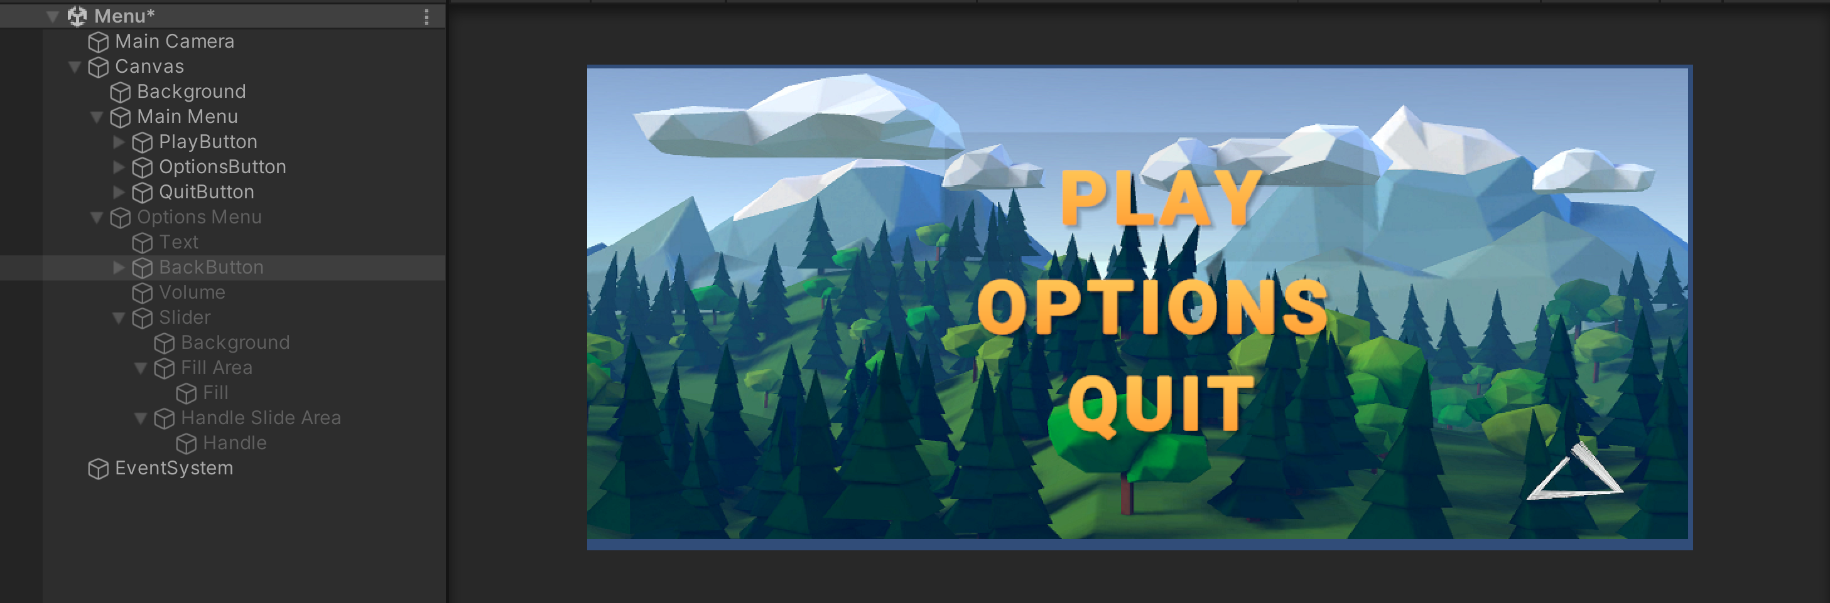

Let us make a functioning main menu. So, I currently have two scenes; a menu one (which is completely empty) and a Sample one (this will represent the game scene).

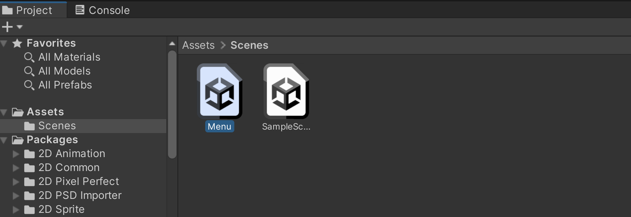

Inside of our menu scene let's begin by creating the UI. Let's right click in our hierarchy go to UI and select “Panel” this will create a canvas and inside of this canvas it will create a panel.

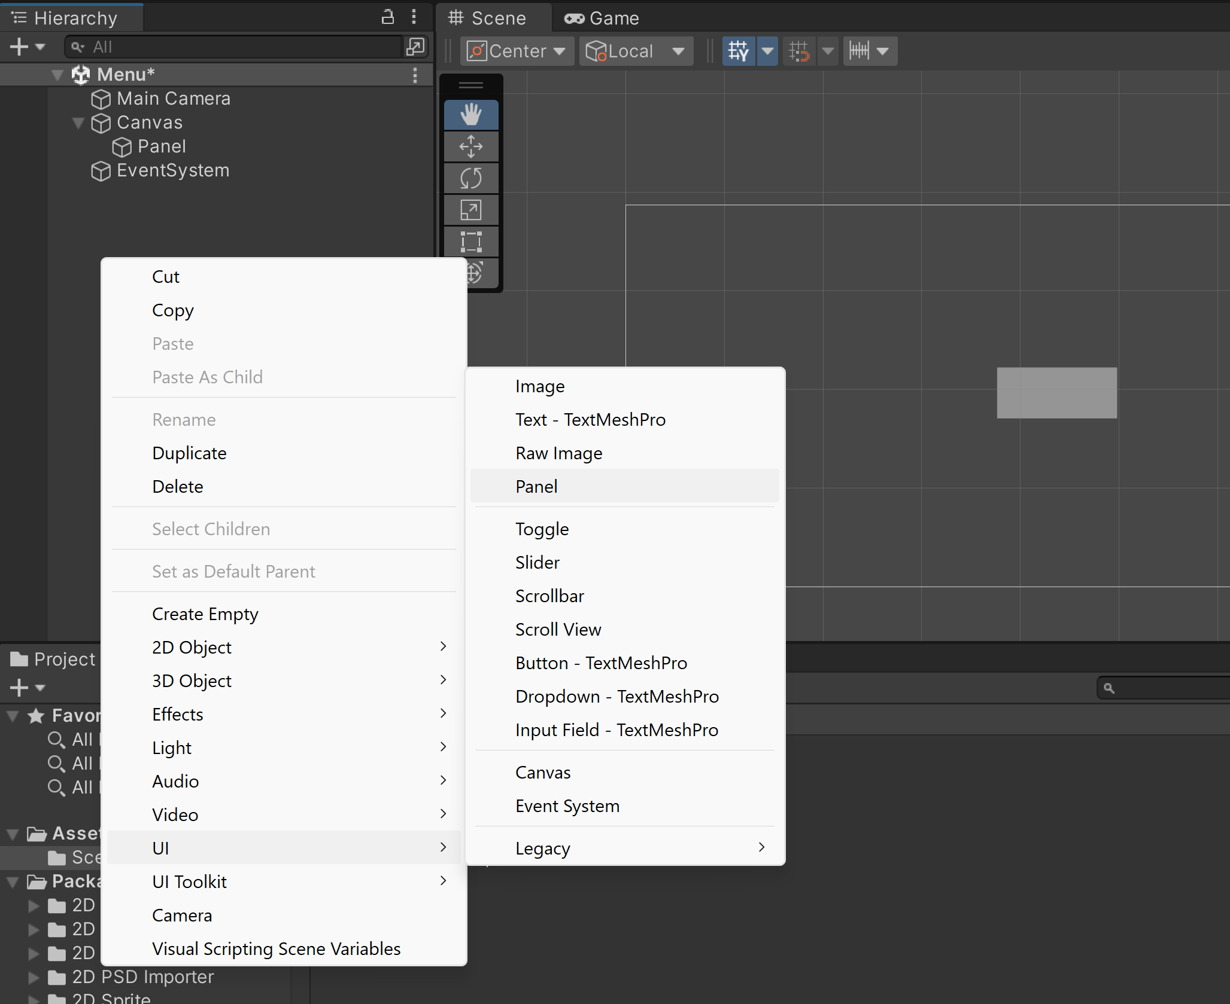

Now go to your inspector tab and I want you to go under image and replace the source image. I’ve imported my own background image here that we can drag in.

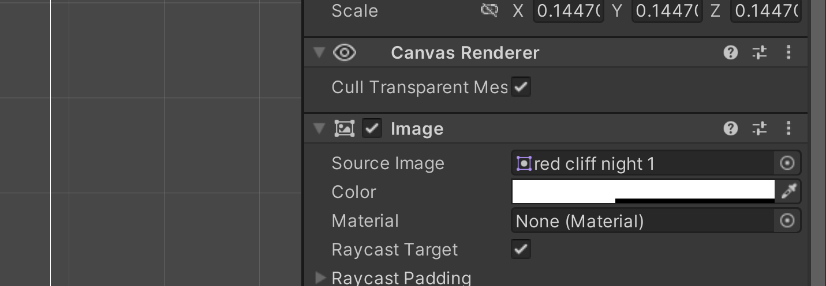

You can choose to use any sprite here just make sure that when you select it, under texture type it's set to “sprite 2D and UI”

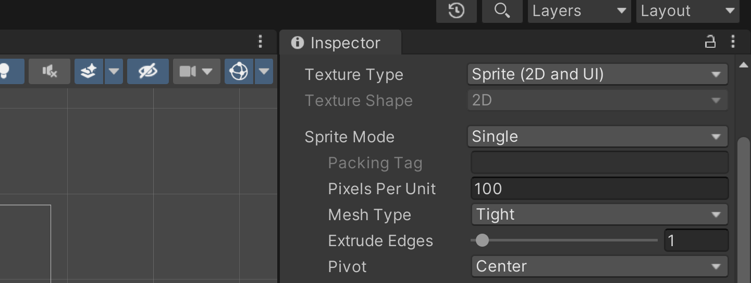

Under our panel let's go to colour and let's amp up the alpha channel.

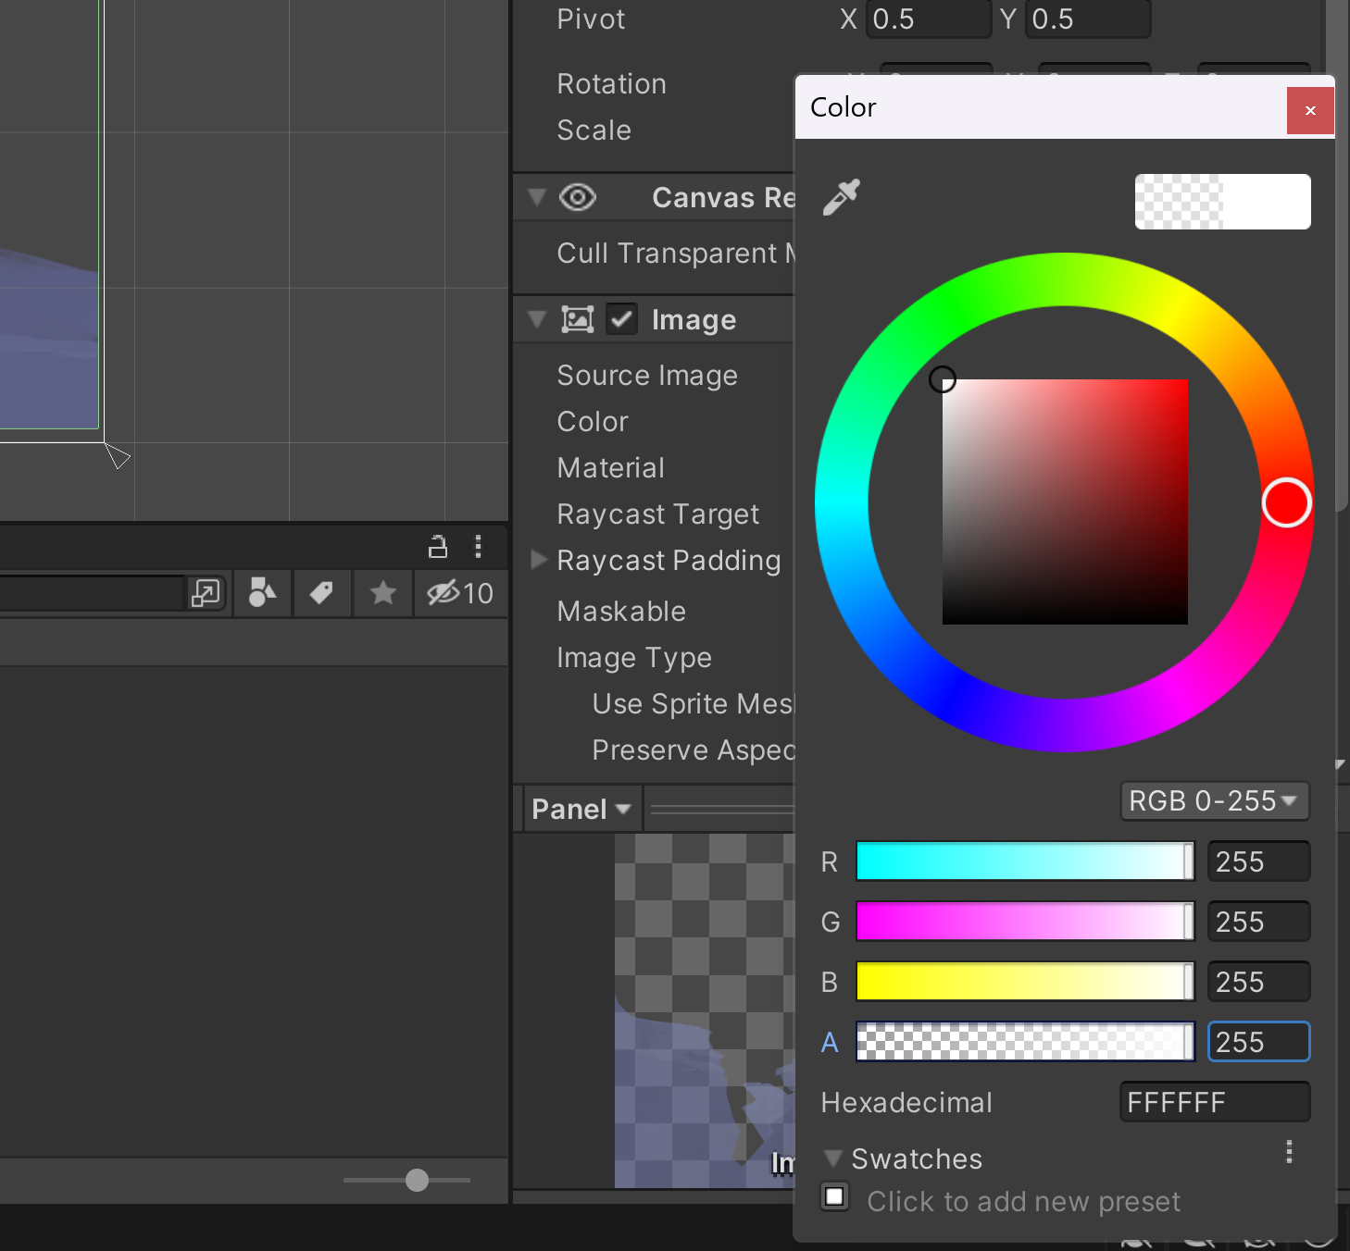

So now we have a nice backdrop for our menu, let's rename it to background and at this point we're ready to add some text.

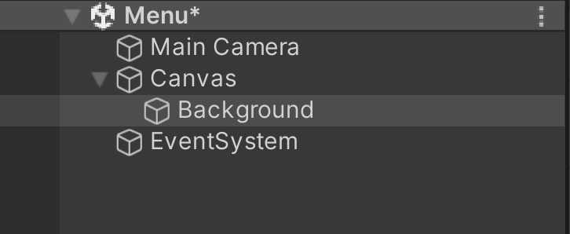

Let's right click on our canvas, go UI, select text and of course we could just use unity's default text here. We could scale it up, centre it, change the font size and the colour.

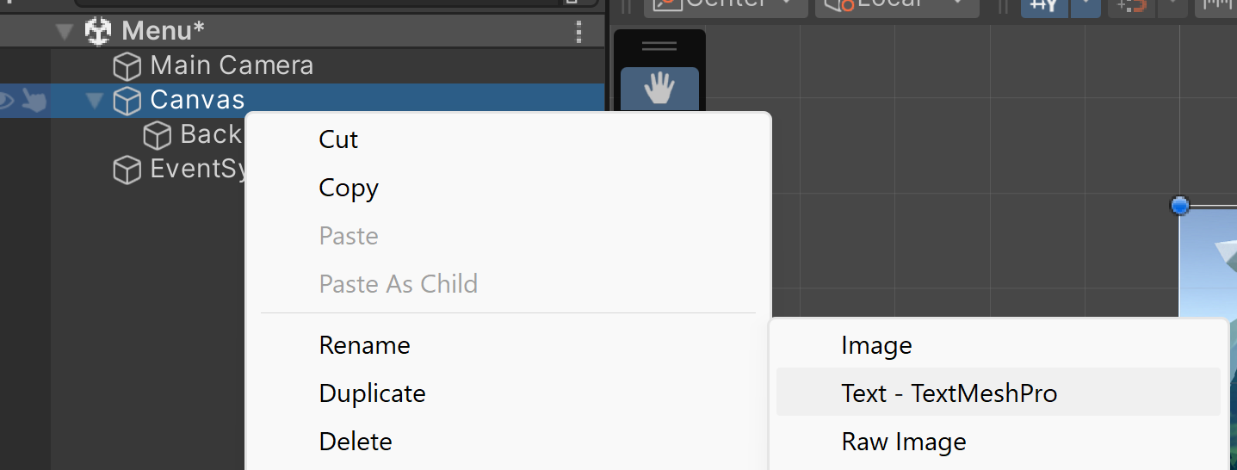

if you want to change the font, we need to import some custom fonts, so instead let's delete this text object and let's import a free package called “text mesh pro”.

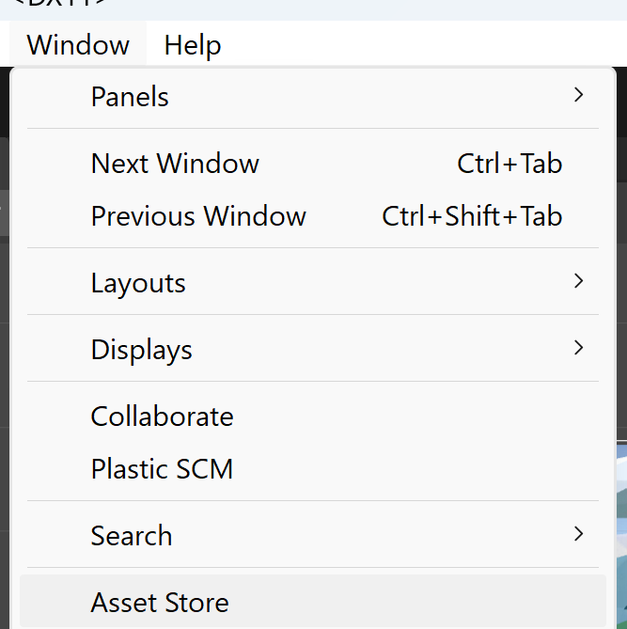

Let's go to the asset store search for text mesh pro.

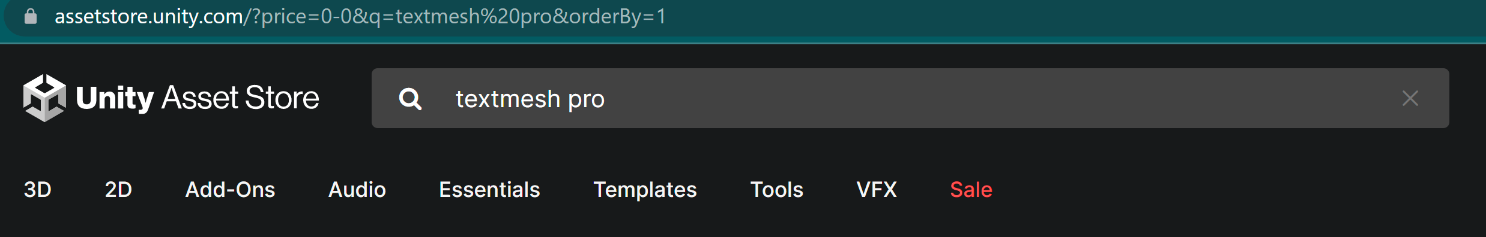

Now we can just hit download or import, and we'll hit import again and after it's done you should see a folder in your project panel called “text mesh pro”.

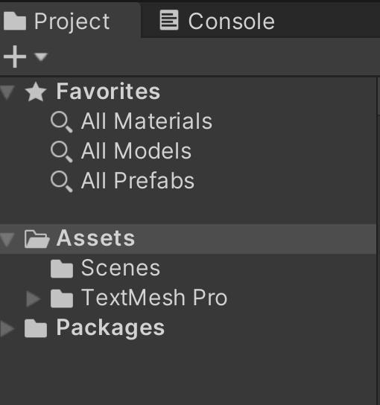

We can go back to our scene view we can right click on our canvas go UI and you should now see an option here called “text mesh pro text” and straight away we can see that the text renders a lot more clearly.

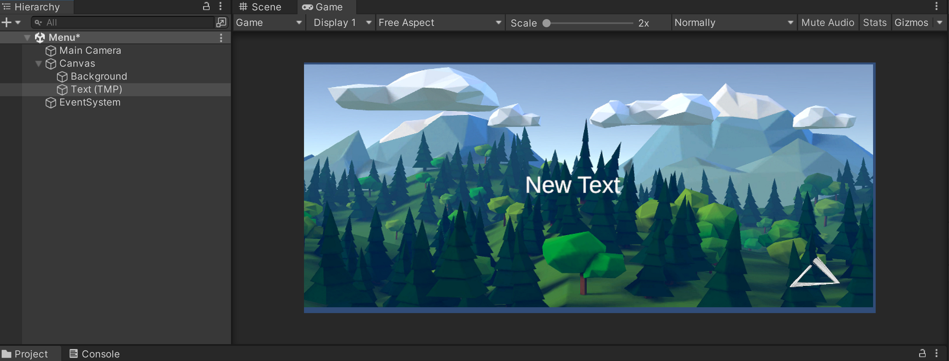

Go into the font size and change it to 60, hold down alt to scale from the centre, let's make sure to align our text to the centre both horizontally and vertically. Now, instead of “new text” we'll write “play” with capital letters and I’m also going to change the font asset to “Robot0-Bold SDF”, and we can make this even more bold so that's also on the font style, check off the **B.**

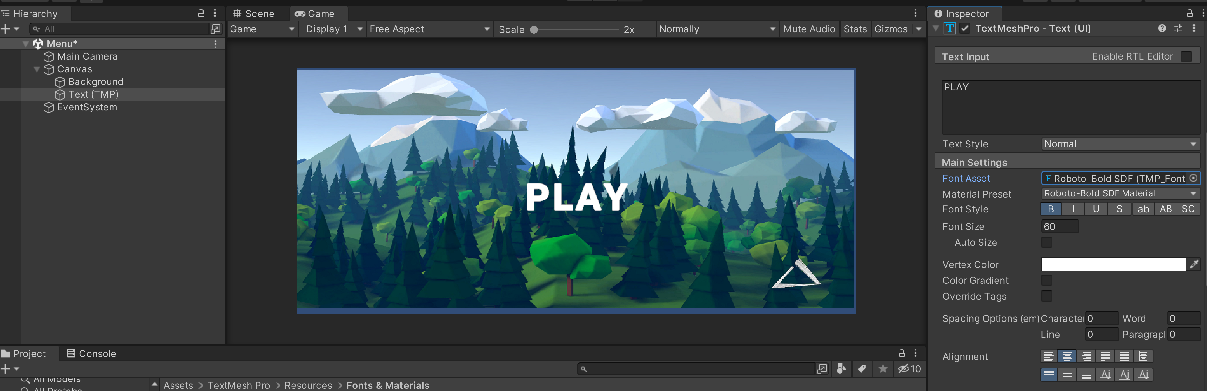

**C**urrently, it's just a plain white text, to change this scroll down onto the material settings first and add an underlay to create a shadow. Enable this and let's offset it by 1 on the x by -1 on the y. We can also increase the softness to play with the shadow a bit.

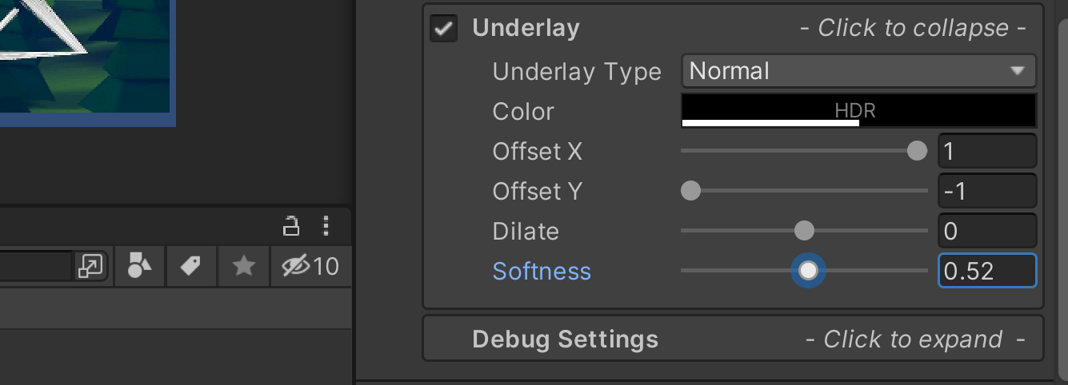

Add a gradient to the text; we do that under the font settings where it says “colour gradient” we'll make sure to check that and we now configure a colour for both the top left and right and the bottom left and right.

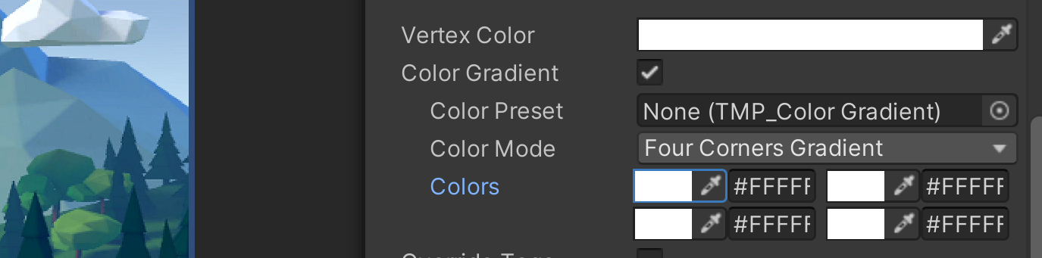

Instead of doing that in here, since I want all of my text elements to share the same gradient, we can create a colour gradient asset. To do that we'll go to Project, right click, go create text mesh pro and let's select colour gradient let's rename this asset to gold.

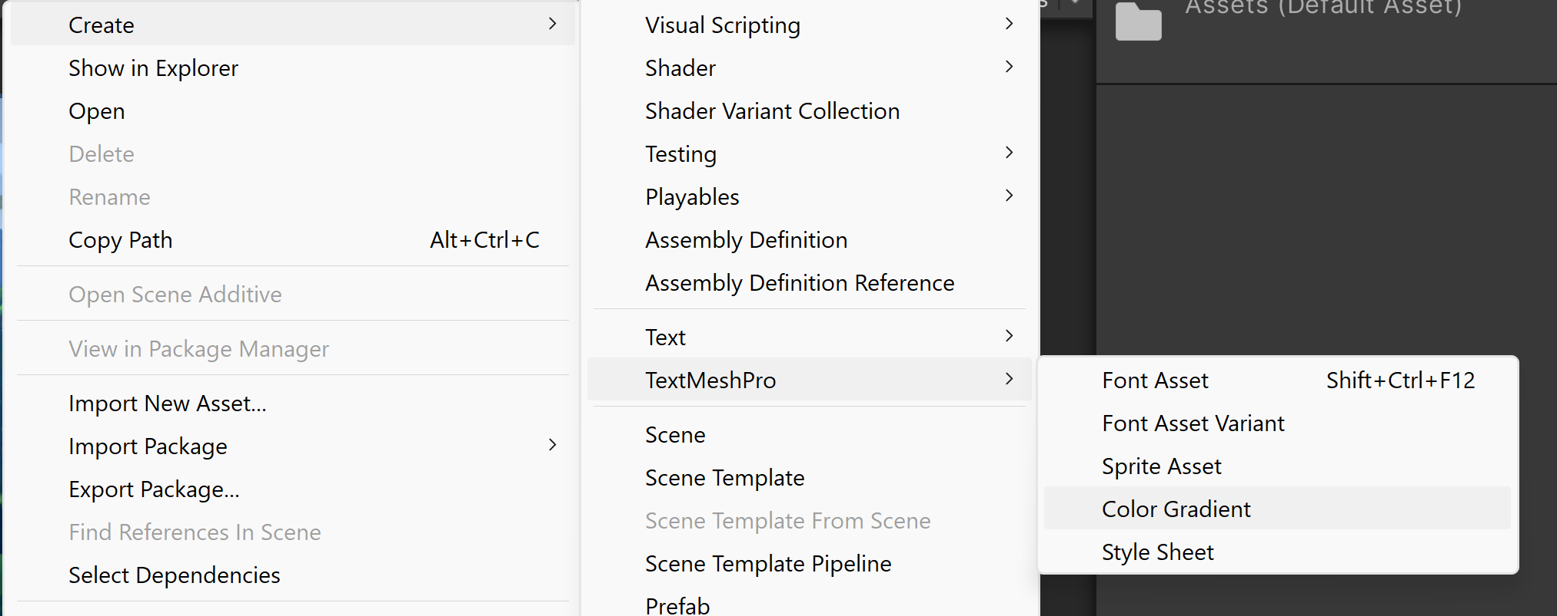

We can define some colours and I have some colour codes here that I use:

Top left #FFC757

Top right #FFC757

Bottom left #FF9C31

Bottom right #FF9C31

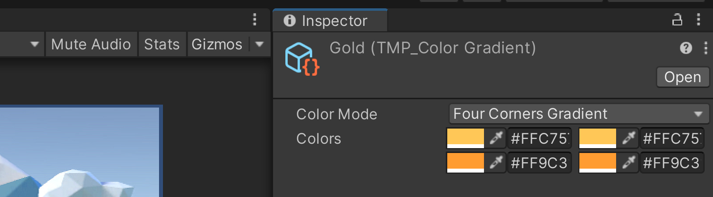

Select your text object, scroll to the gradient part, and drag in our gold object into the gradient preset slot and there we go we now have a nice gradient to our text.

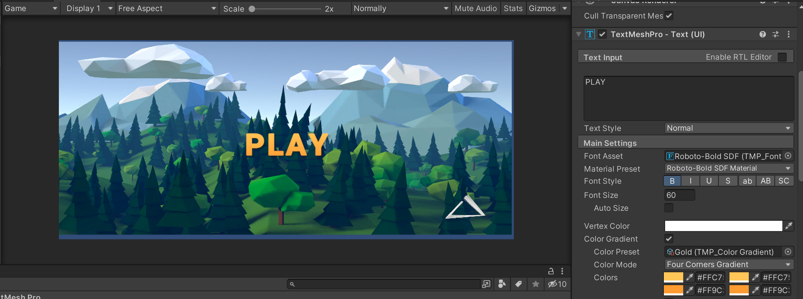

Rename this text to “Play” and this is currently just a symbol text object, we want to turn this into a button. To do that let's right click on our canvas go UI and create a button.

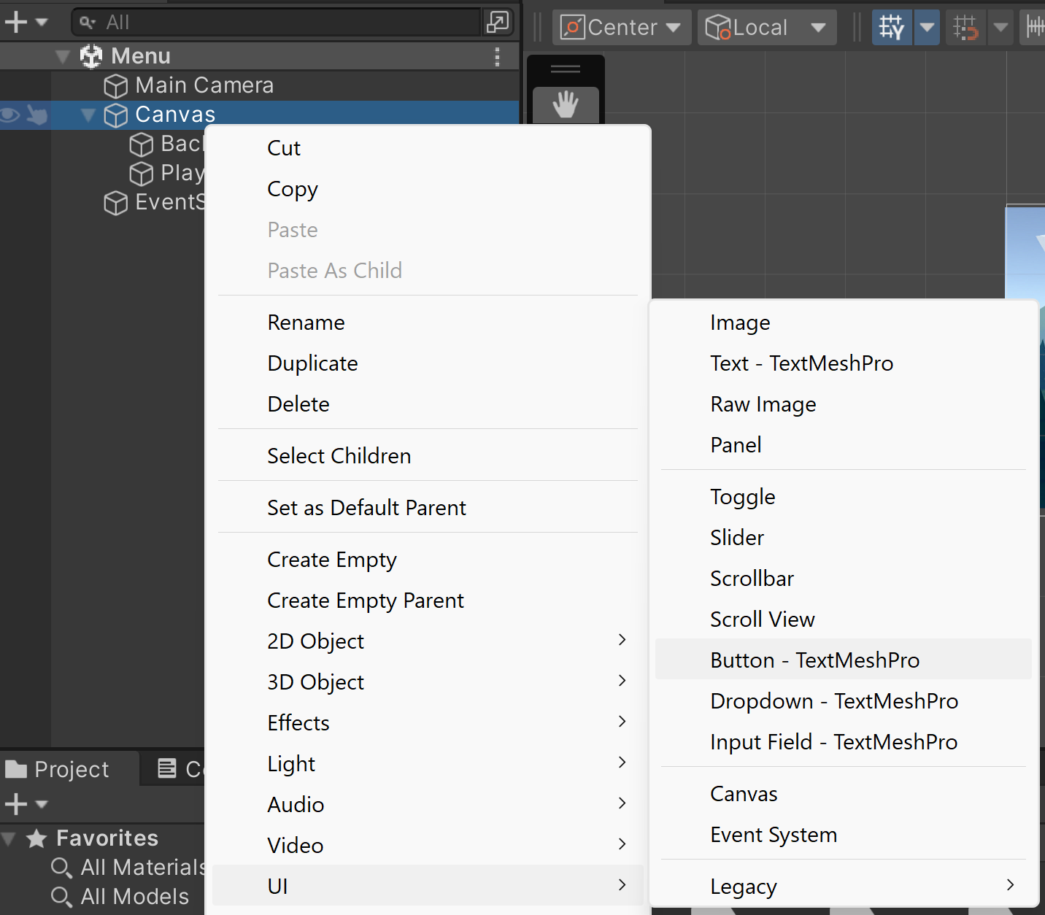

Start by scaling this button up and let's move it up as well for the image here we'll make that completely black and for now we'll just go ahead and disable it.

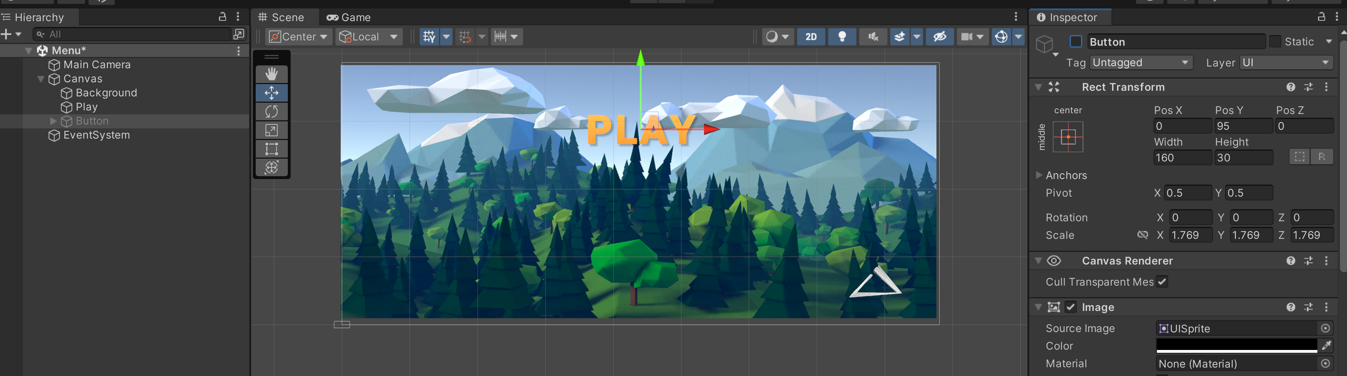

Then under our button we'll notice a text object, and this is what we want to replace with the play text that we just created. So, delete this text object and instead drag in our play text just rename this to text and instead rename our button to “play button”. We now select our text object we'll click on the anchor presets at the top of the regular transform, hold down alt and click on the bottom right corner this will snap our text to the centre of our play button and make sure to always scale it to the same size as the button.

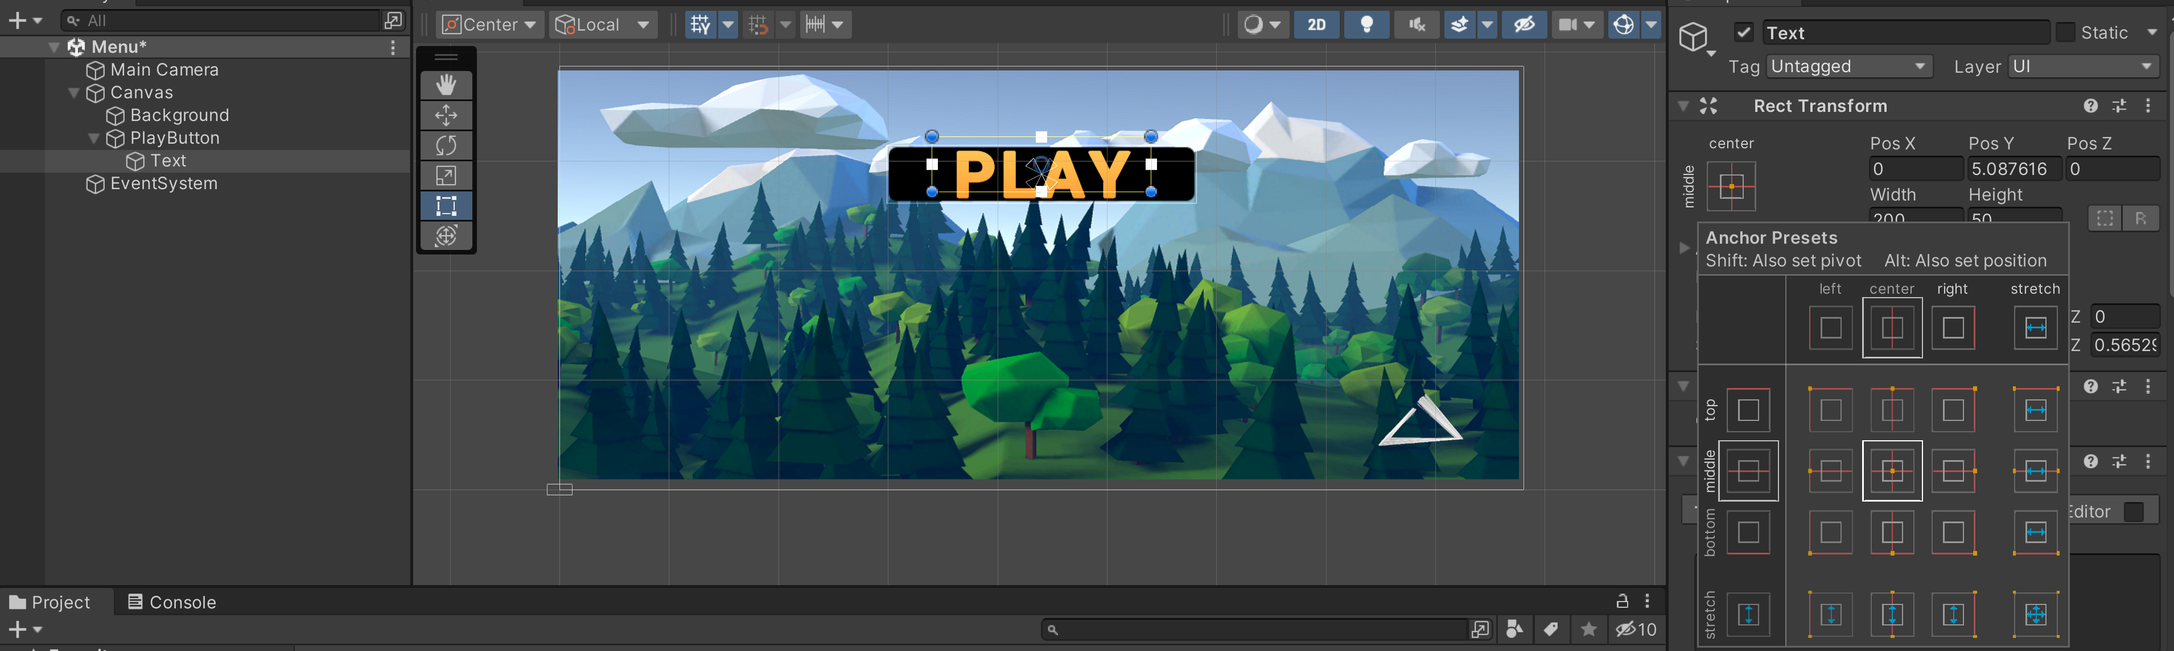

Now we should see that if we hit play, we can actually press on our text however we don't actually see anything changing we need some visual feedback on what's going on. To do that, re-enable our image under the normal colour let's go and change the alpha to zero.

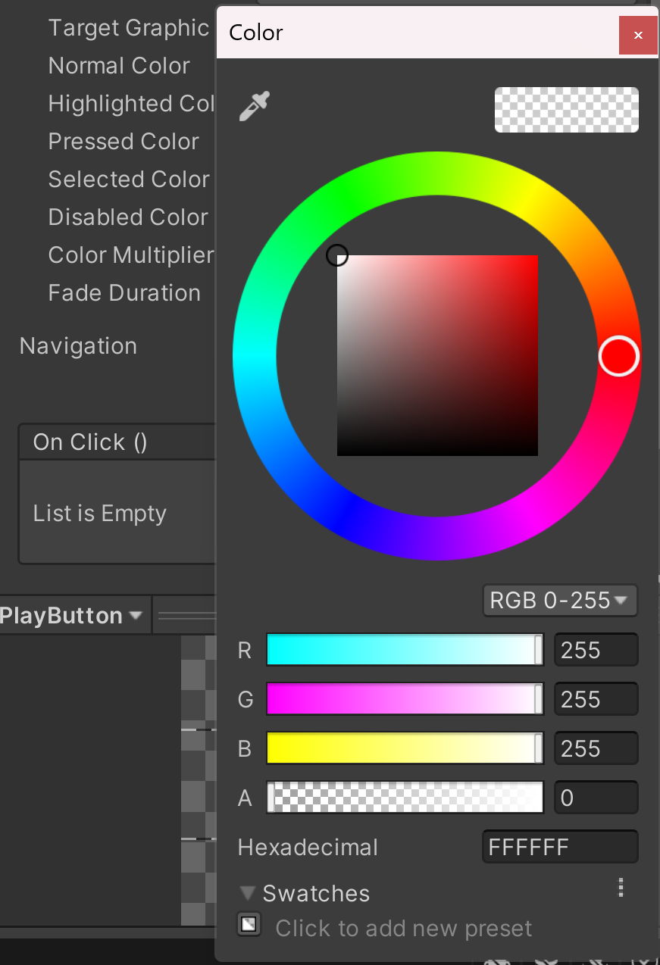

Under highlighted colour we'll also decrease it, but we do want it to be visible and when we then press the object, we want it to be even clearer.

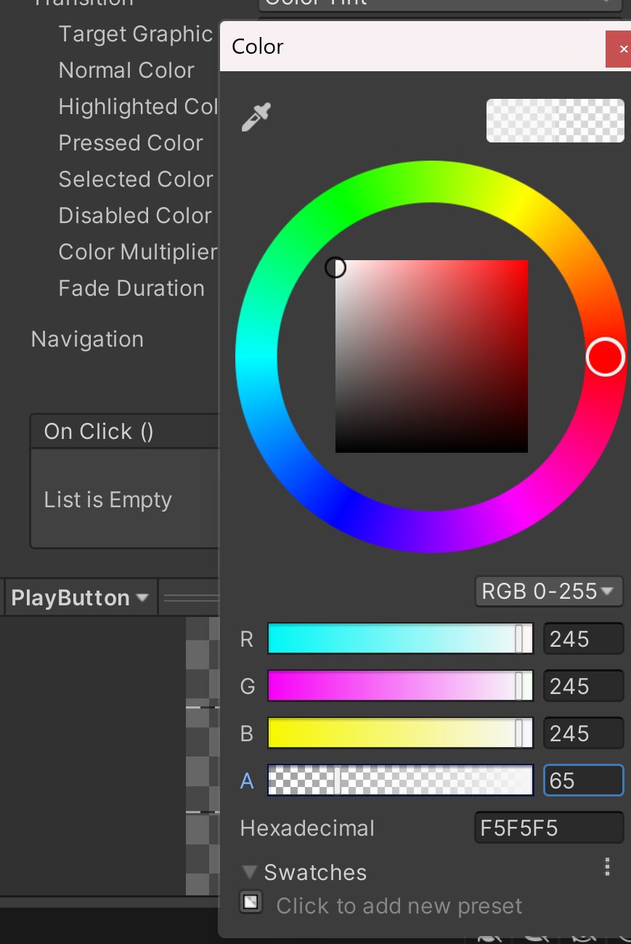

With these settings if we try and hit play we should see that when we hover over our text the black box appears and when we click it, it becomes even darker.

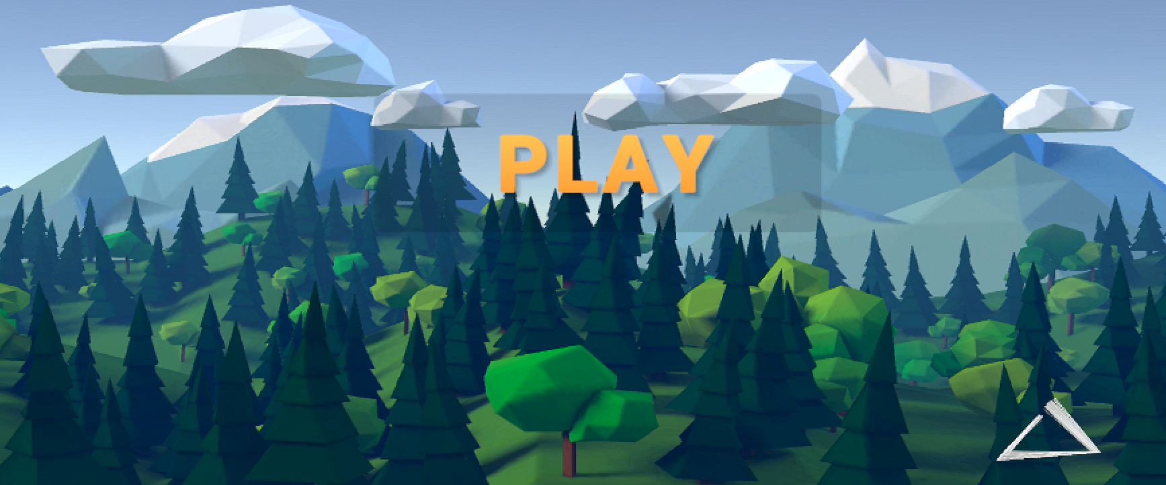

We can of course change the size of the black box by adjusting this element so when you’re happy with your button let's go ahead and duplicate it. We'll click and drag while holding down shift to move it down on only one axis and this is going to be our options button. Change the text to “options” and increase the width to make room for it and rename it to “options button”. Again we'll duplicate this hold down shift while moving it down and finally we want this to be our “quit” button. We'll resize again it to only just fit our text and we then rename the button to “quit button”. Now hit play, we should see that we're able to select three different buttons and that you can also use your keyboard to change between them.

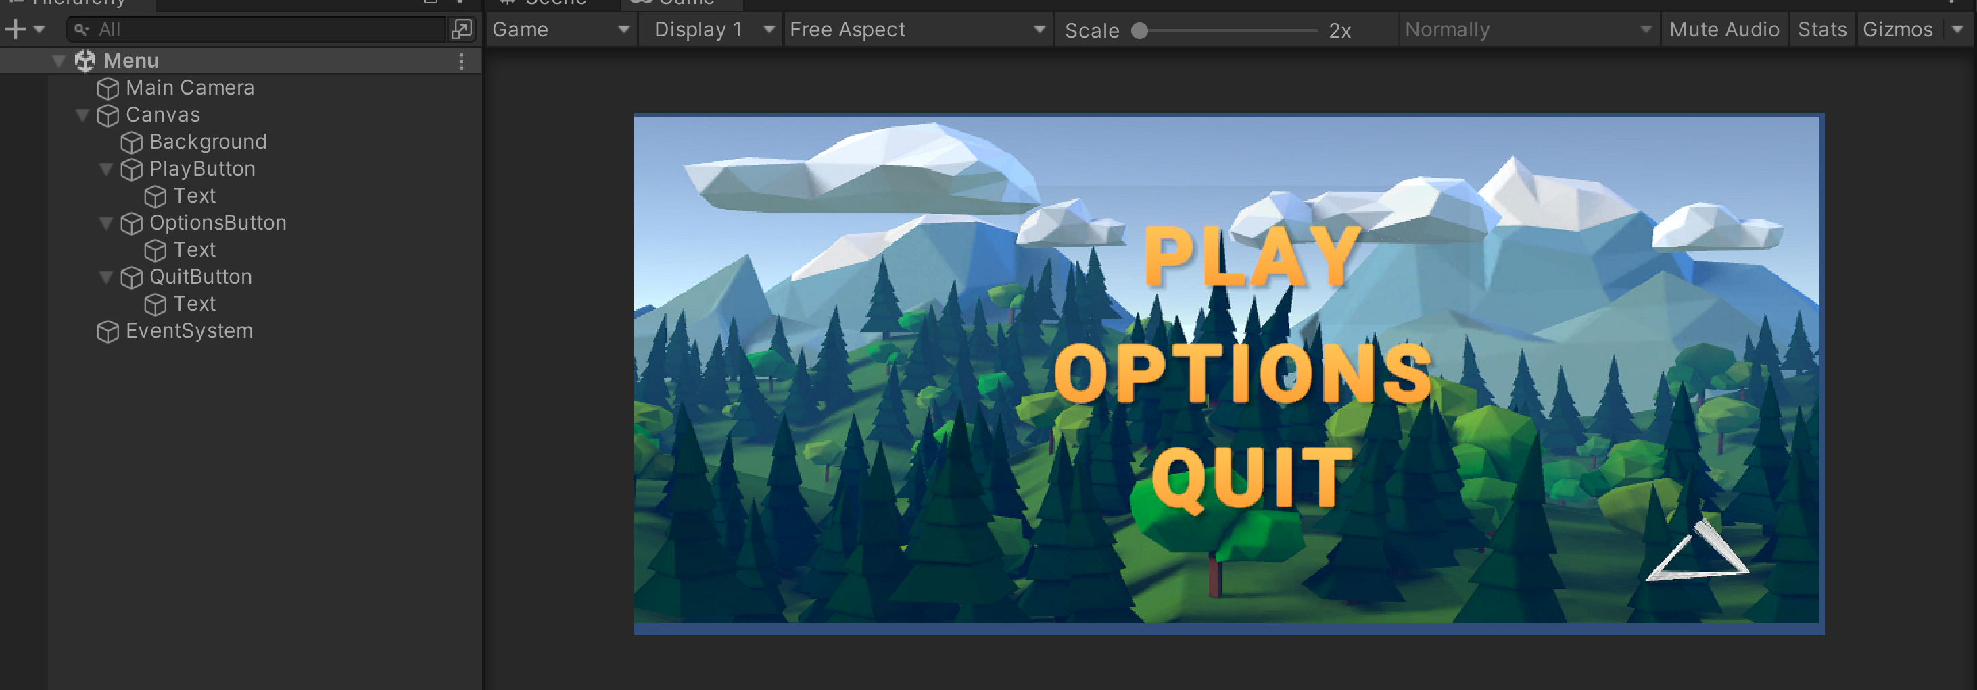

Of course, your buttons currently do not do anything. Your play button should load the next scene, your quit button should close the game and your options button should lead to another menu. Let's start by creating this menu to do that. Go to canvas, let's right-click and create an empty we'll rename this to our main menu. Size it up a bit as this is going to contain all of our main menu elements.

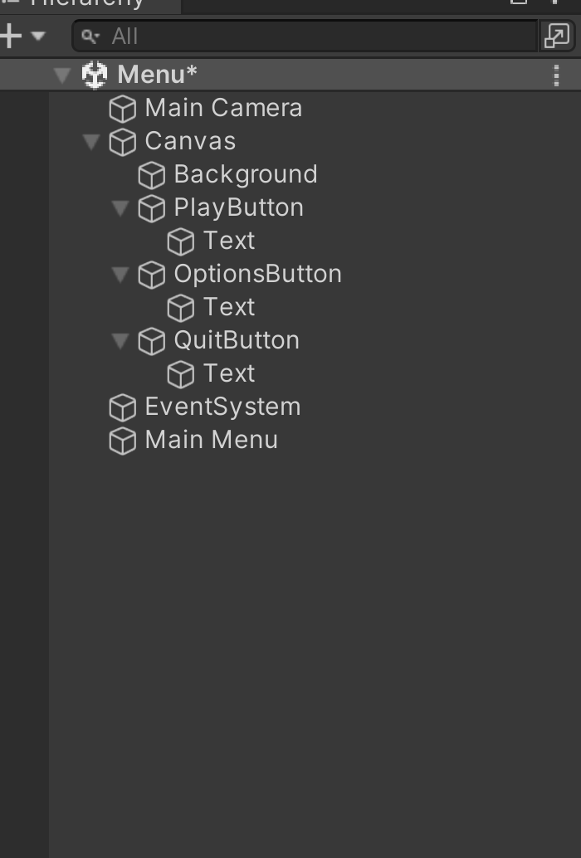

Select all our buttons and drag them under our main menu object. Duplicate this object and rename it to “options menu”.

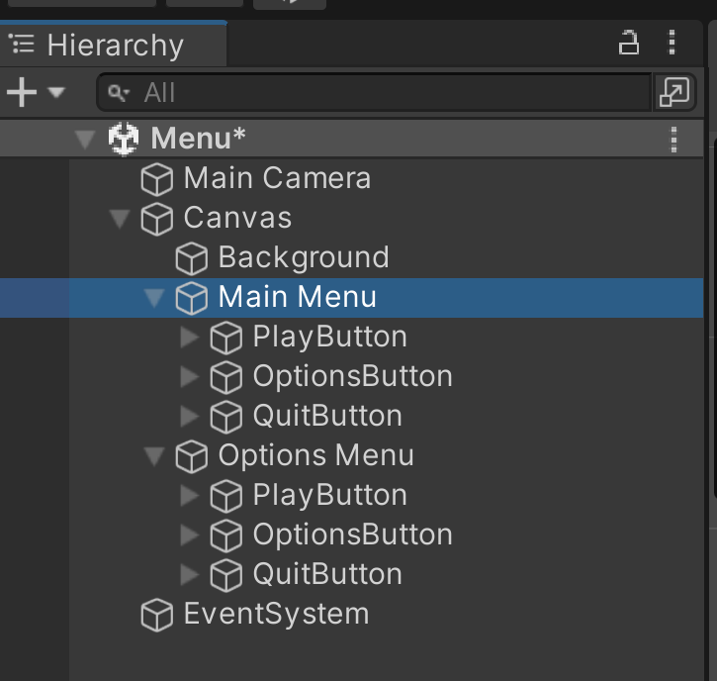

Disable the main menu. For this menu I do not want a lot of buttons, but I do want it to say options at the top. Go under my options button, take the text element alone and drag it to the top; I am then going to drag it up to where it says play. I am going to delete both the play and options button the quit button we can turn into a back button.

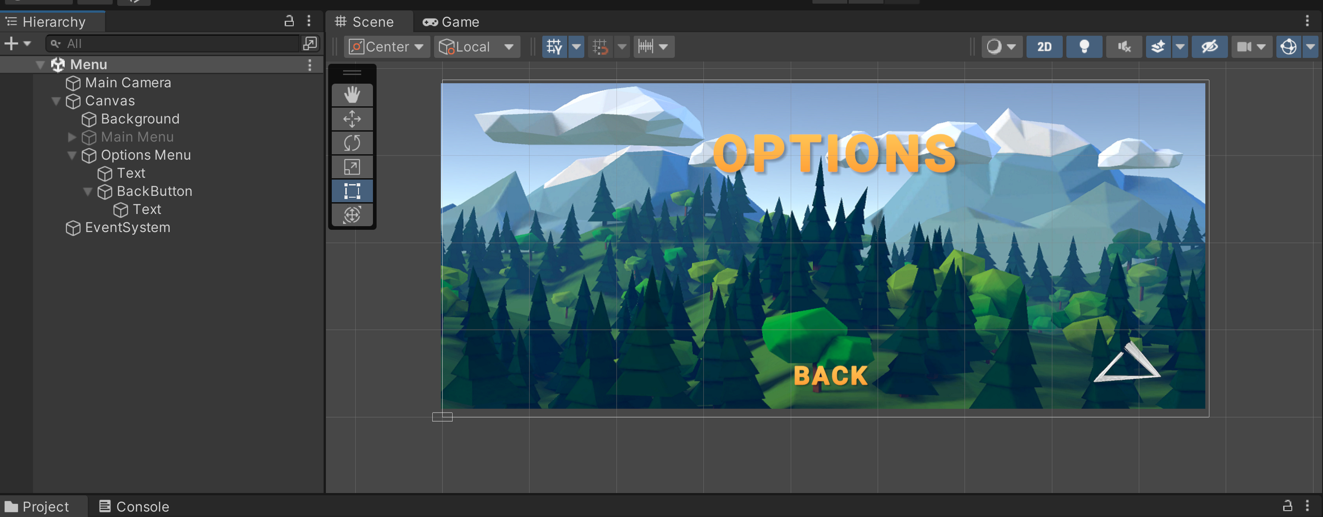

Decrease the text size to something like 30 and we'll then resize it to fit. Now we have some room where we can add our settings.

I’m going to show you how to add a simple slider. First, right click on your “options menu” go to UI and select slider.

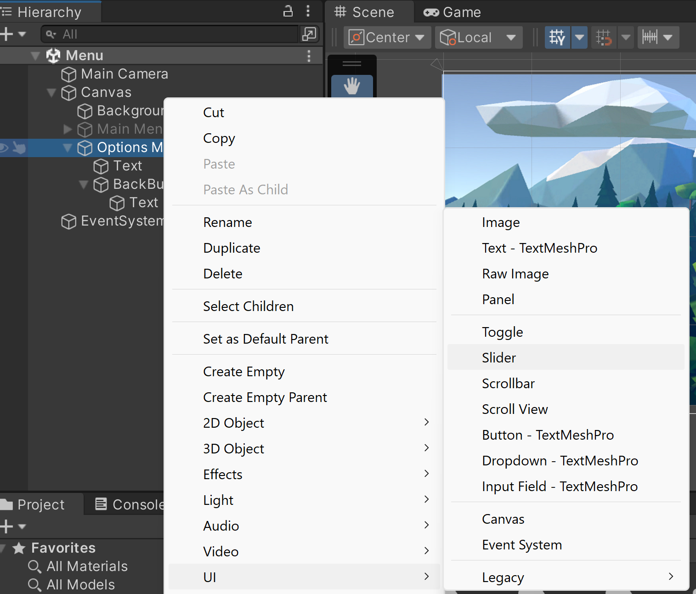

Size the slider accordingly and now let's go into the slider find the handle and let's disable the image component.

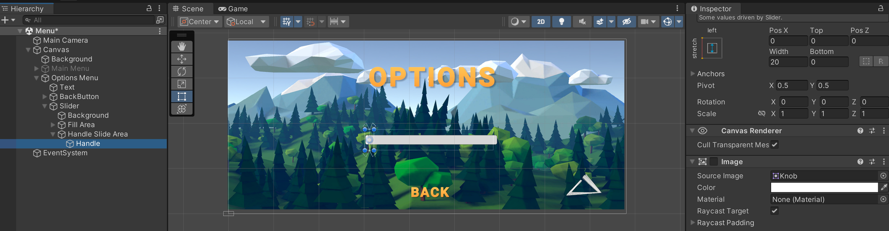

We can then select our background and make this a neutral black let's also decrease the alpha to not make it stand out too much.

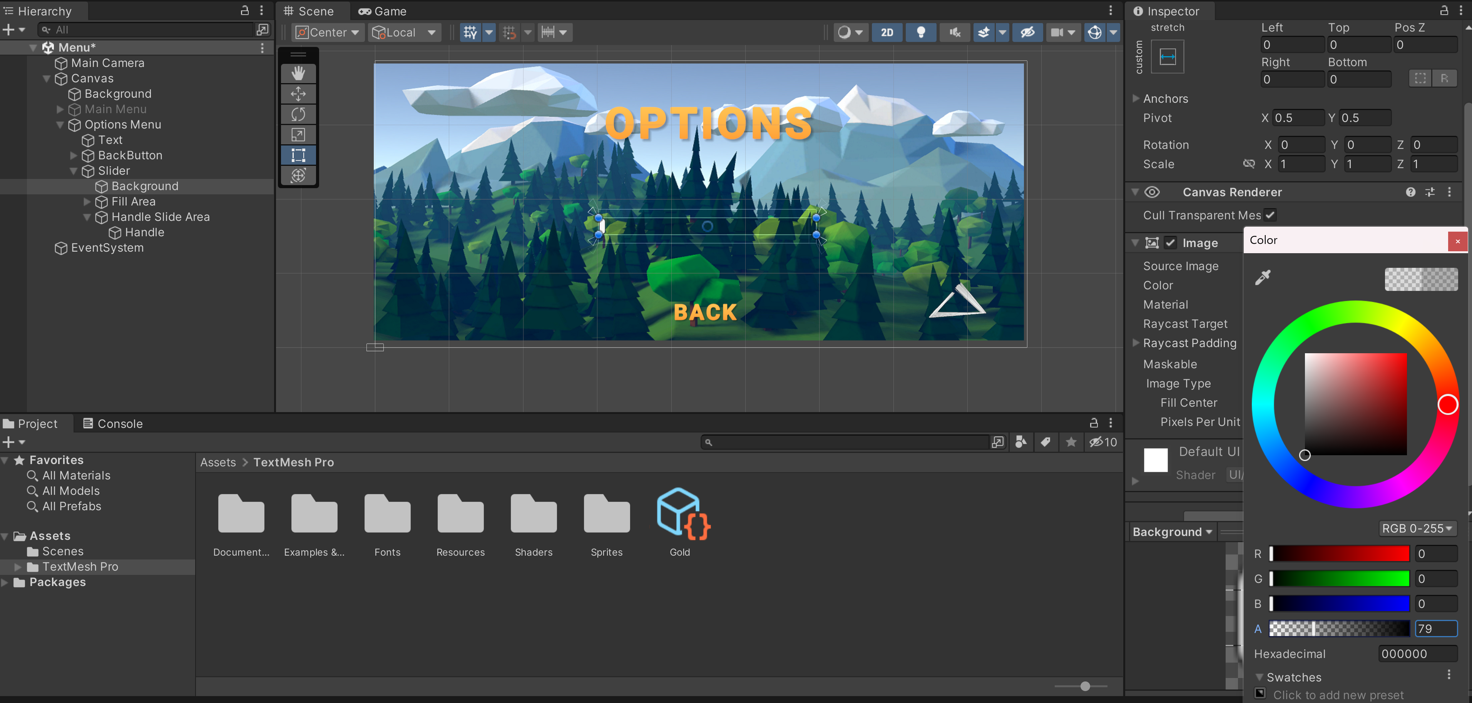

Finally go under fill area and select fill and let's use the colour picker here to get a nice colour from the text.

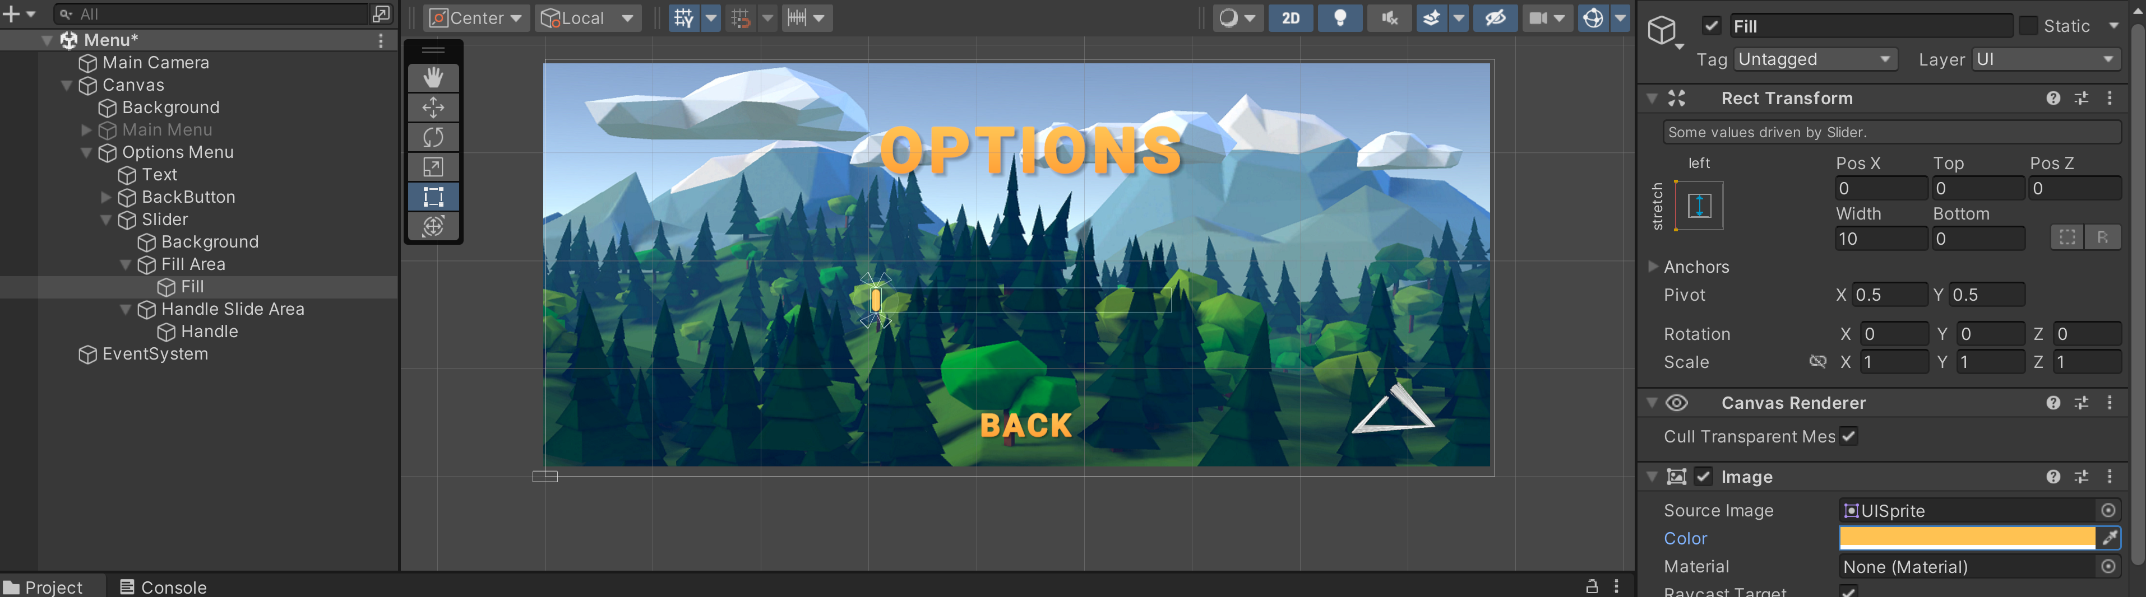

You should see if you hit play that you’re able to adjust your slider to anything that you’d like. Add a tiny text element telling what the slider does. To do that let's duplicate our text and move this on top of the slider and let's rename this to “volume”.

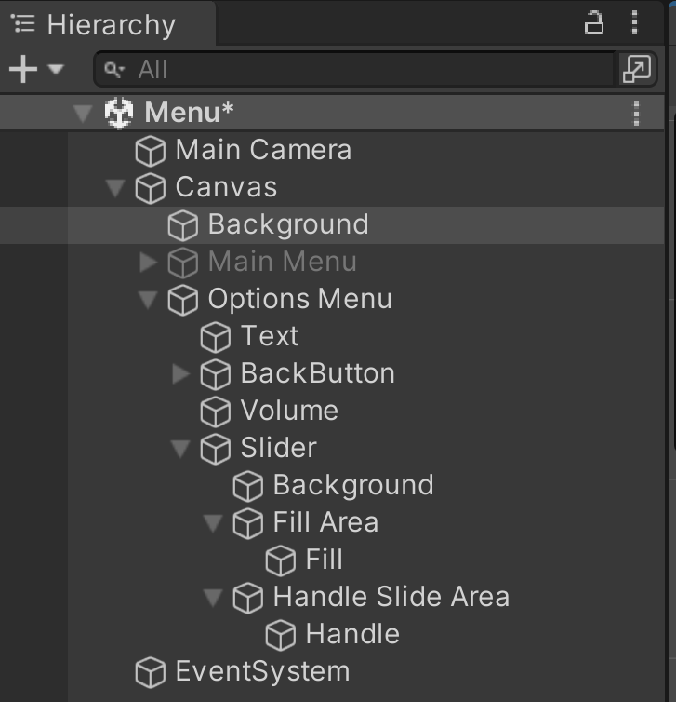

Change the text to volume as well and decrease the font size to something like 18. We now shrink down this element move it to our slider and adjust accordingly. We have now created a volume slider. Of course, a slider does not change any settings.

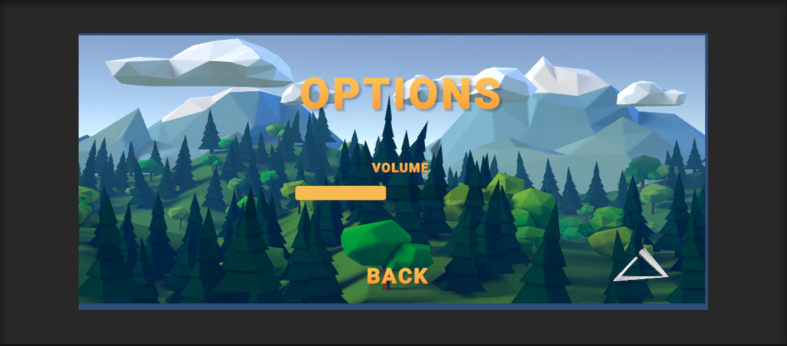

You now have two menus: an options menu as well as a main menu all that's left is to add functionality to these two menus.

Let's begin with the play button this is found under the main menu object. Instead of adding a separate script for the play button itself, let's add a script to the main menu object that will have functionalities for all of our menu buttons.

Hit add component and let's write main menu let's create a new script of type C#. Create an add then double click it to open it up in visual studio.

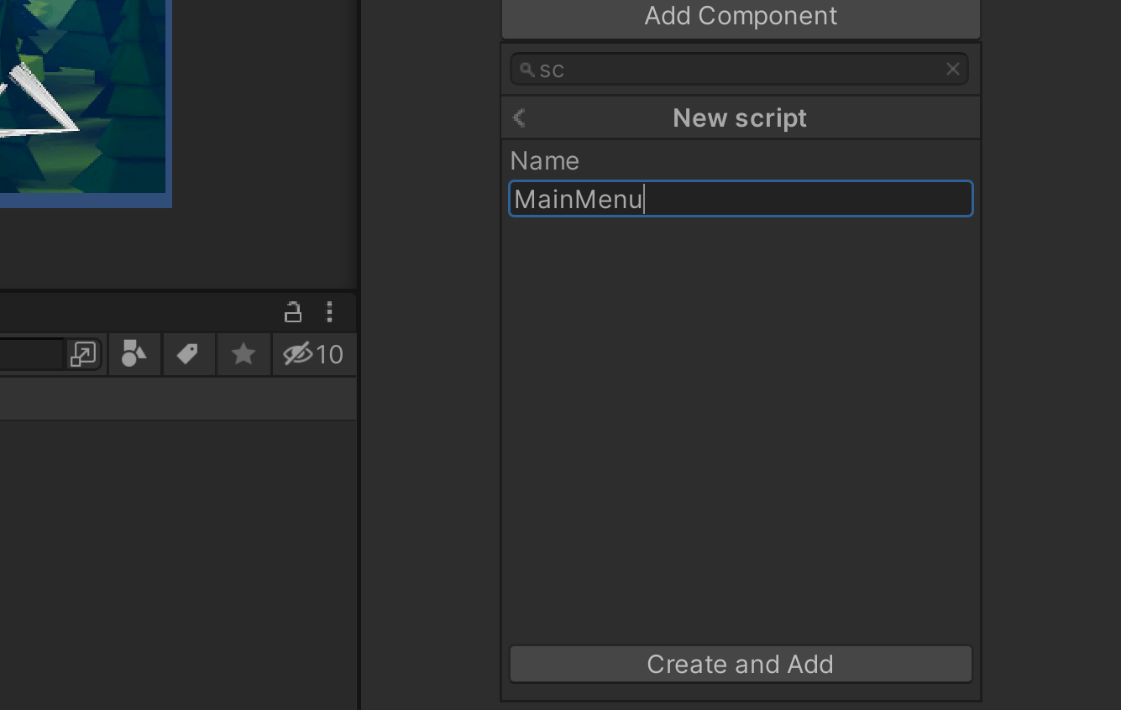

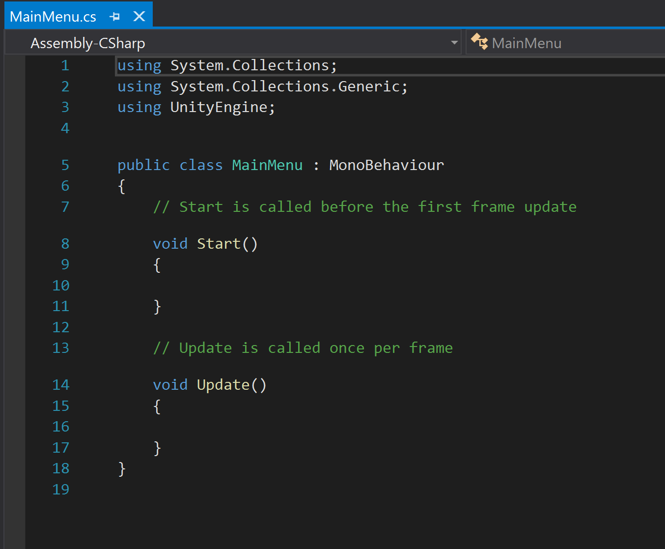

Remove start and update and instead let us create our own function that will call whenever we press the play button. in order to be able to call it from the button, we need to make the method public so we'll write “public void” and let's call it “PlayGame”.

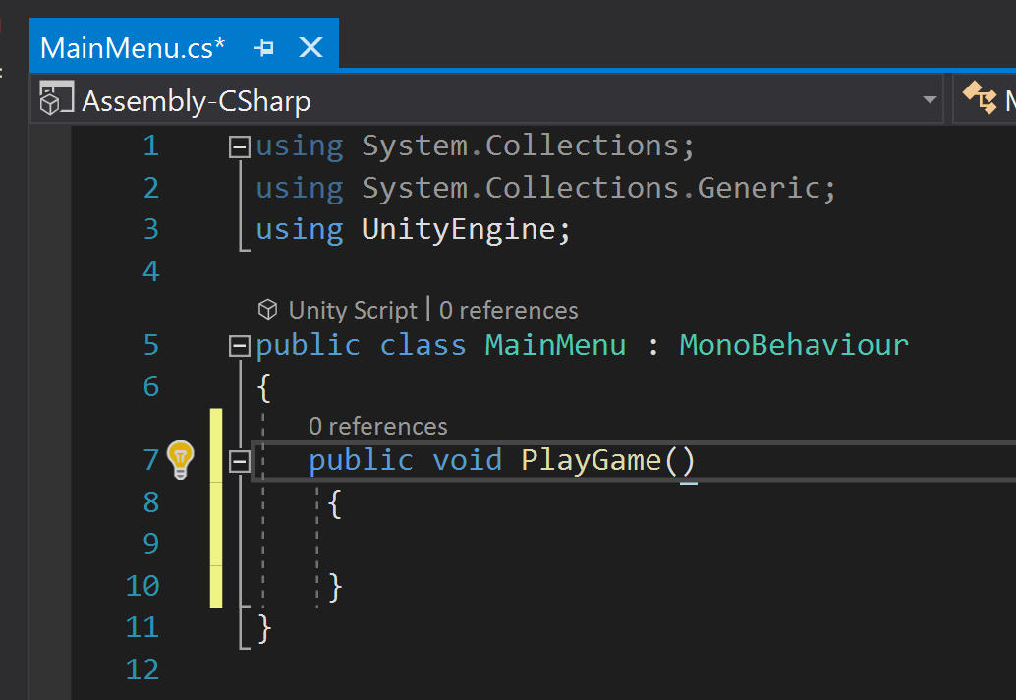

Inside this method we'll simply load the next level. Whenever we want to change scenes in unity we need to be using “UnityEngine.SceneManagement”. Now we can simply go “SceneManager.LoadScene” and here we could give it a name of the scene say “level1” we could also give it a build index say 1; but instead of loading a particular level simply load the next level in the queue. To do that we get the index of our currently loaded level “SceneManager.LoadScene(SceneManager.GetActiveScene().buildIndex + 1)”

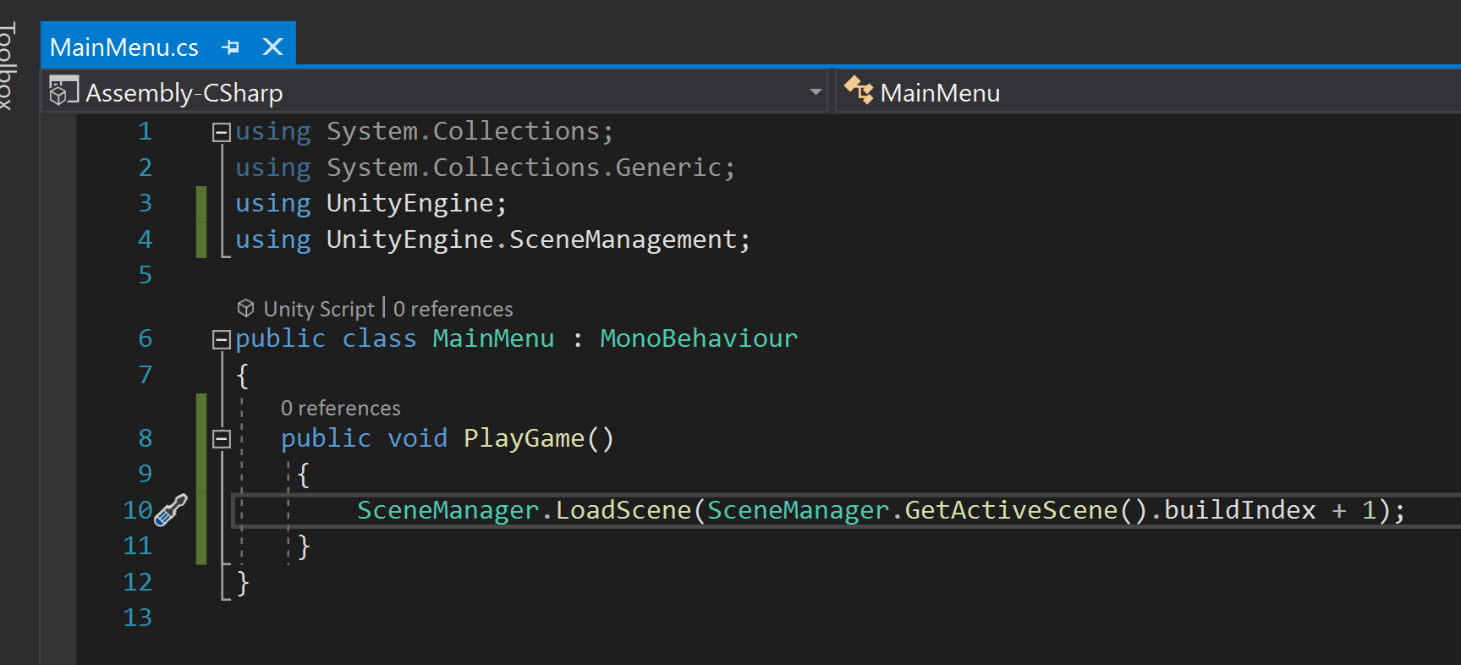

If we now save this and go into unity we of course need to make sure that we add our scenes to the queue. To do that we go file build settings and here we have all the scenes in our build.

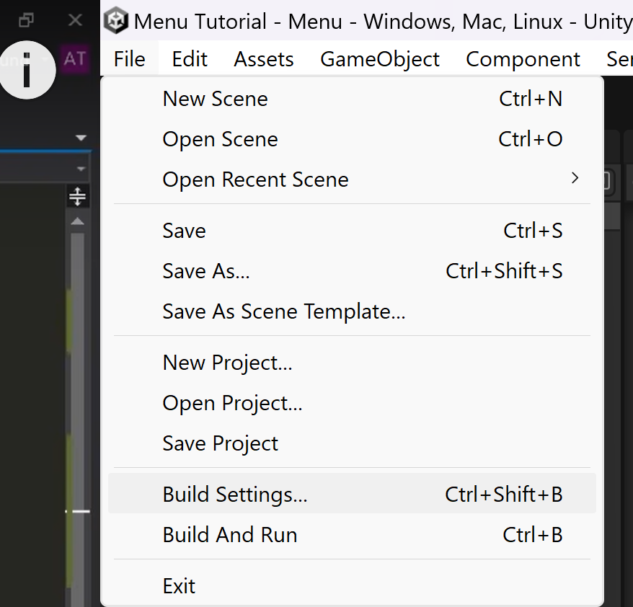

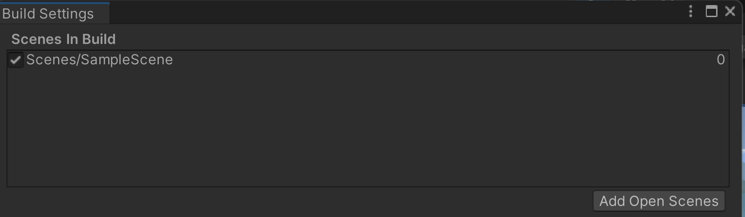

First we want to add our menu so that has an index of 0 I will then add our game which has an index of 1.

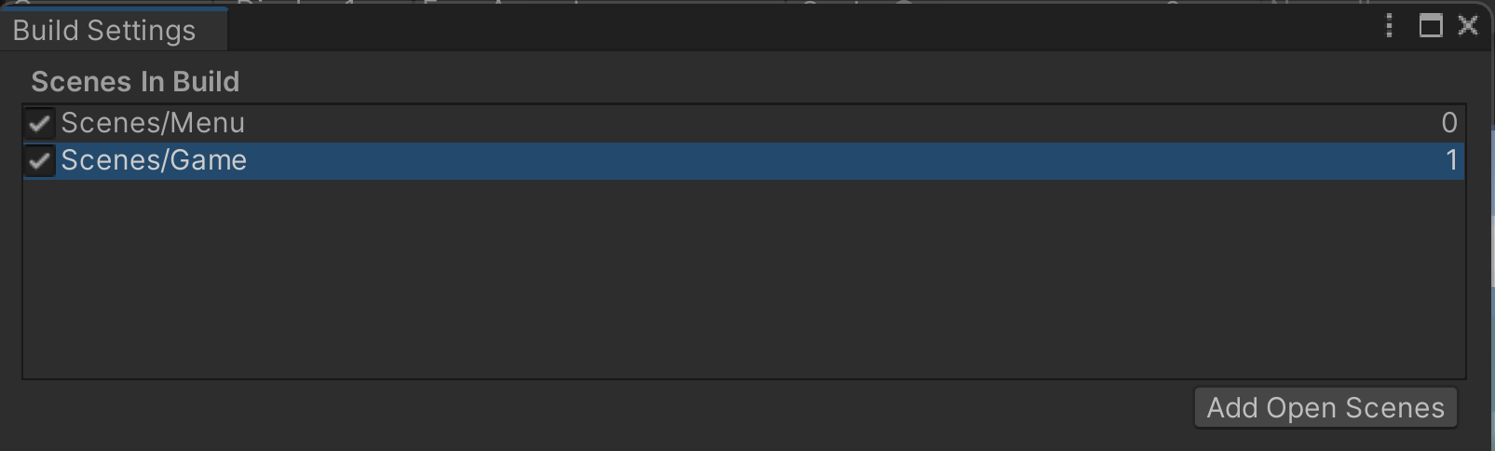

The last thing we need to do is simply hook up our play button to the function that we just created. To do that let's select the button let's scroll down to where it says on click this is a unity event we can add an action to this event by hitting the plus button.

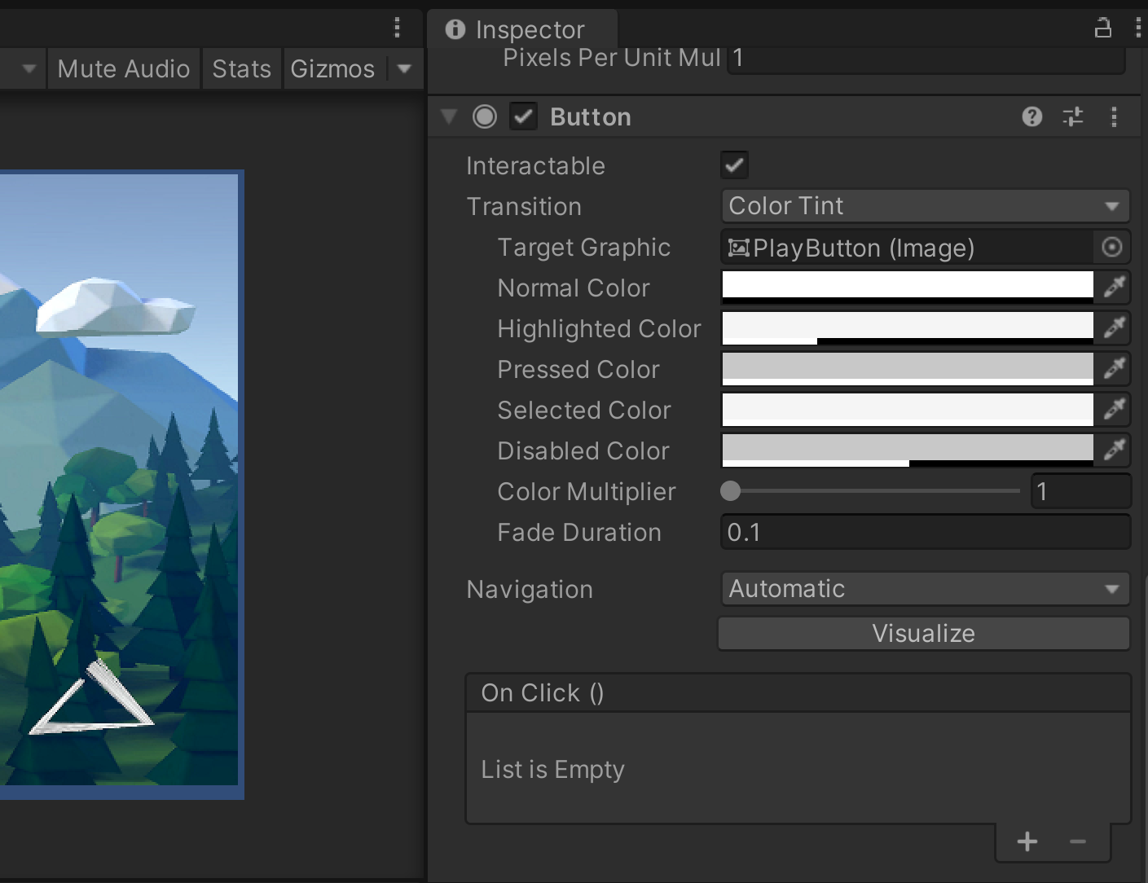

We need to select an object that will be our main menus let's drag that in there now we can go and find our main menu script and under here we've created a function called play game.

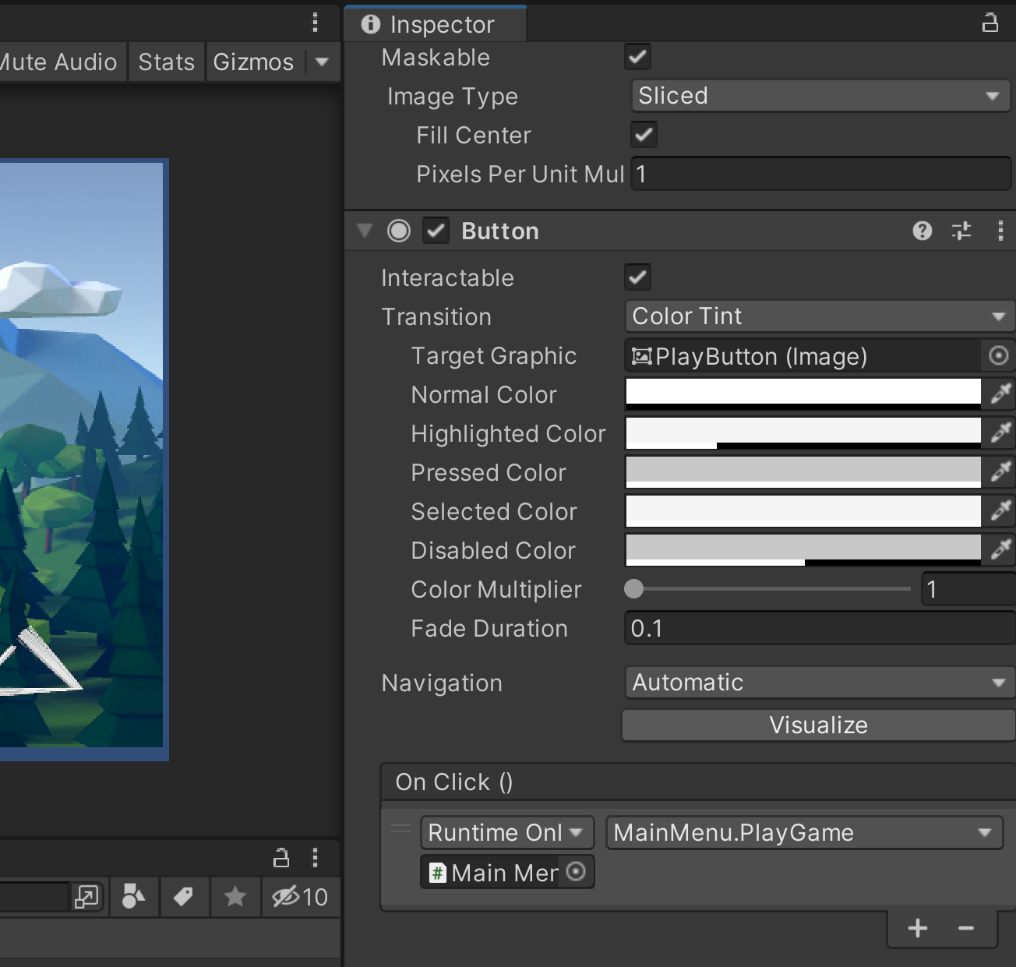

Now if we play our game and press on the play button it loads the next scene which is our game even though currently we don’t have a game. Next, we can do our quit button. Again, we can do this inside of the same script so we'll create another public void and this one we'll call “quit game” and this is even simpler; we simply go: “Application.Quit” and that should close down the program. However, this won't happen inside of the unity editor so just to let ourselves know that this is working we'll use “Debug.Log” and the message will be quit.

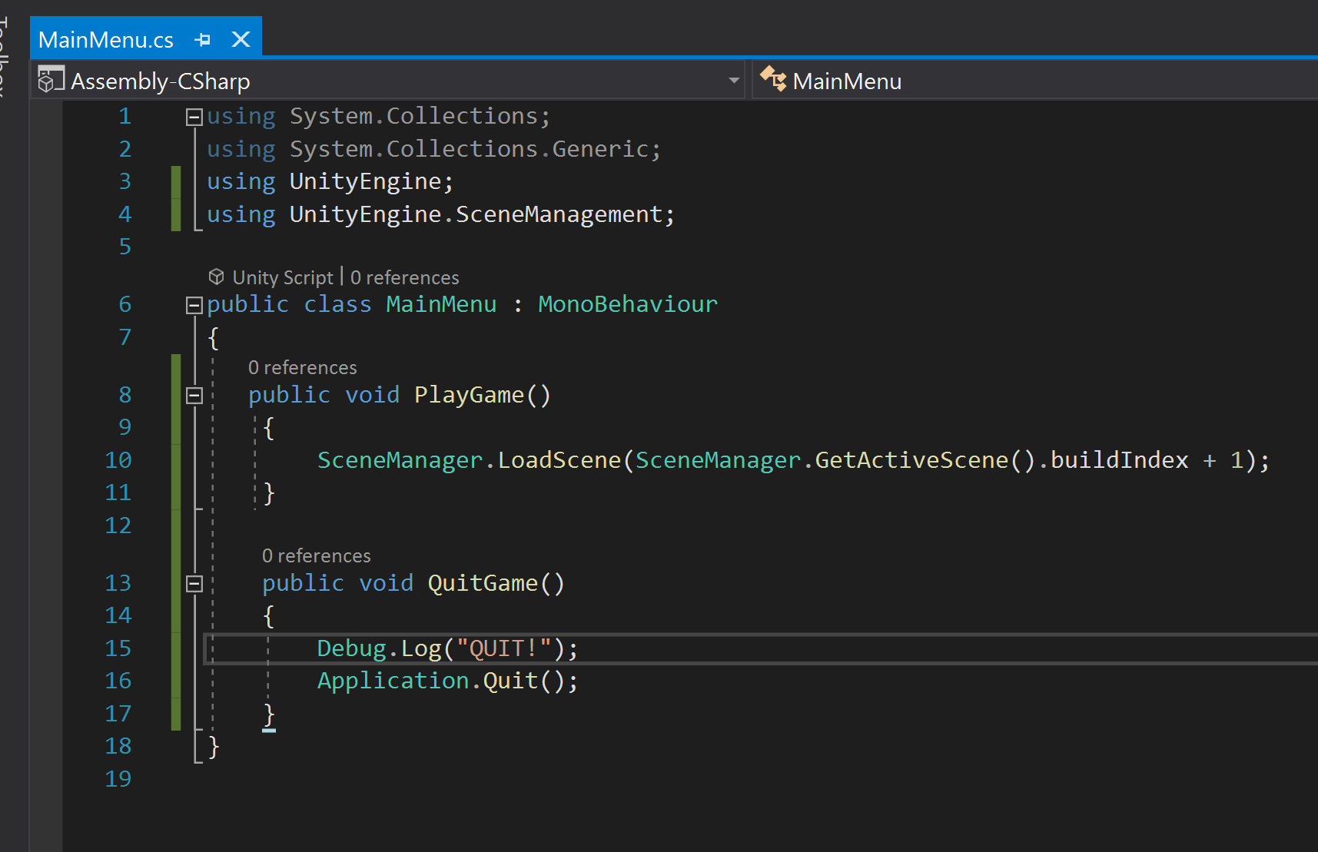

Go into unity, let's select our quit button and scroll down to the on click event. Add an action, again we want to reference our main menu, and the function that we want to call is under main menu and it's called “quit game”.

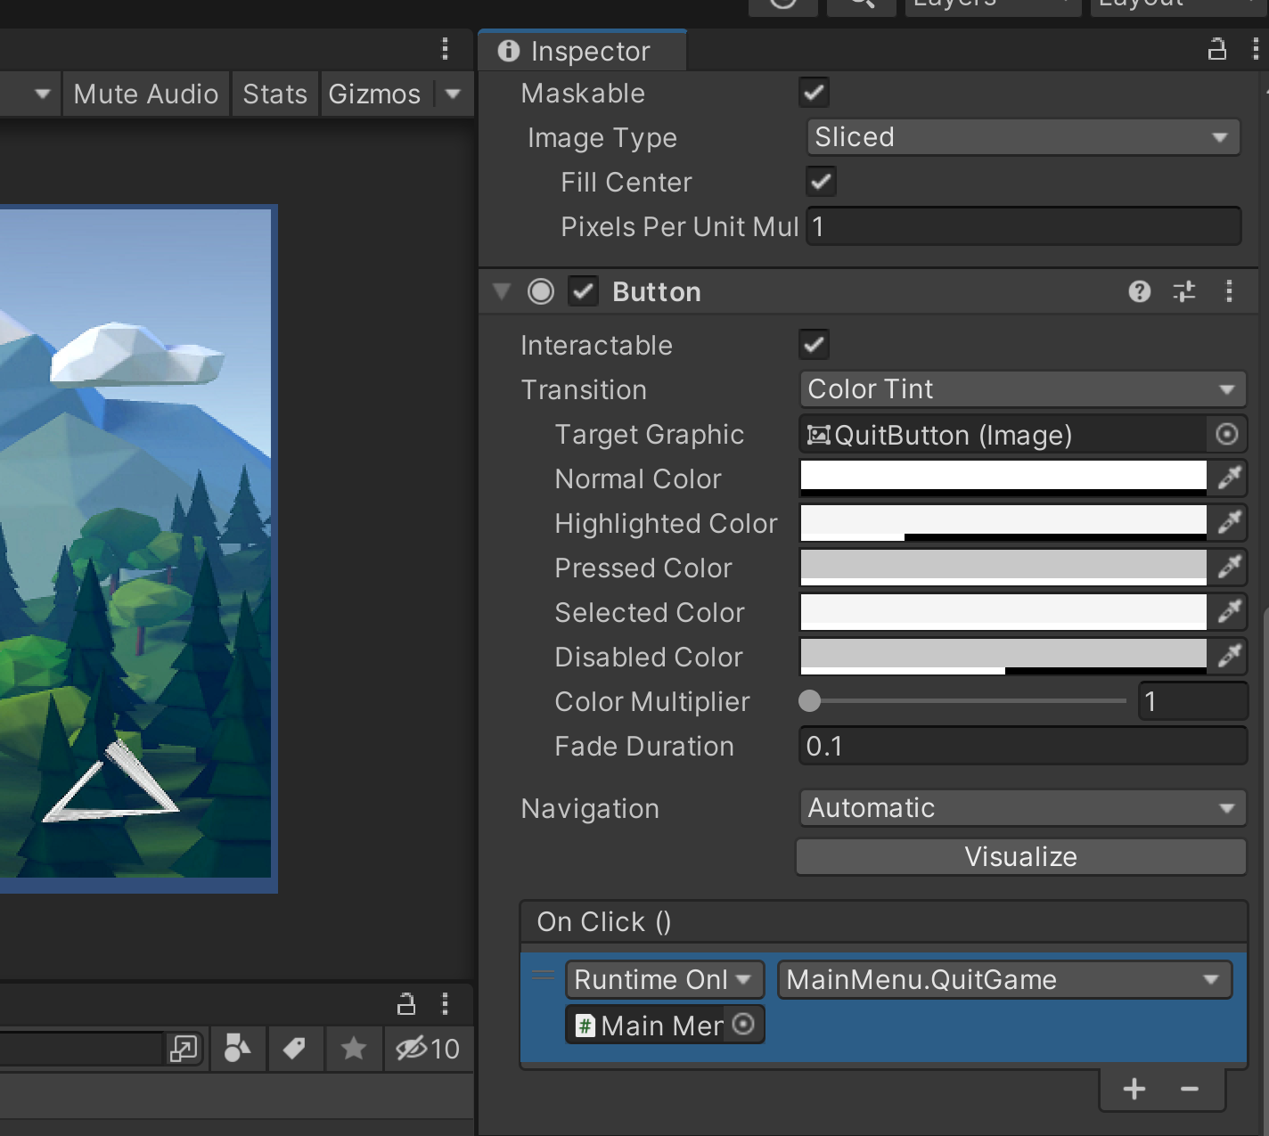

If we hit play and select quit, we now see the quit message displayed in the console.

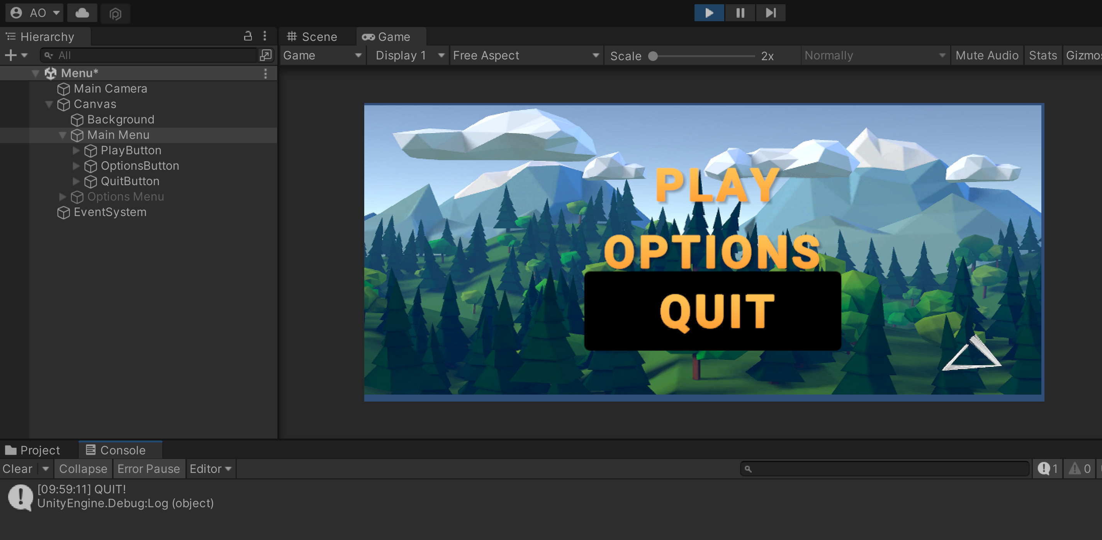



If you build this and try and do the same thing it will close the program now the last button that's left is our options button, that's because we don't want this to load another scene or quit the program, we simply want this to change to another menu. We have that menu available right here it's just disabled so we don't need to do any programming.

Simply select the options button scroll down to the on click event add an action and here we can reference our options menu directly then as the function will go under GameObject I will choose the “SetActive” function.

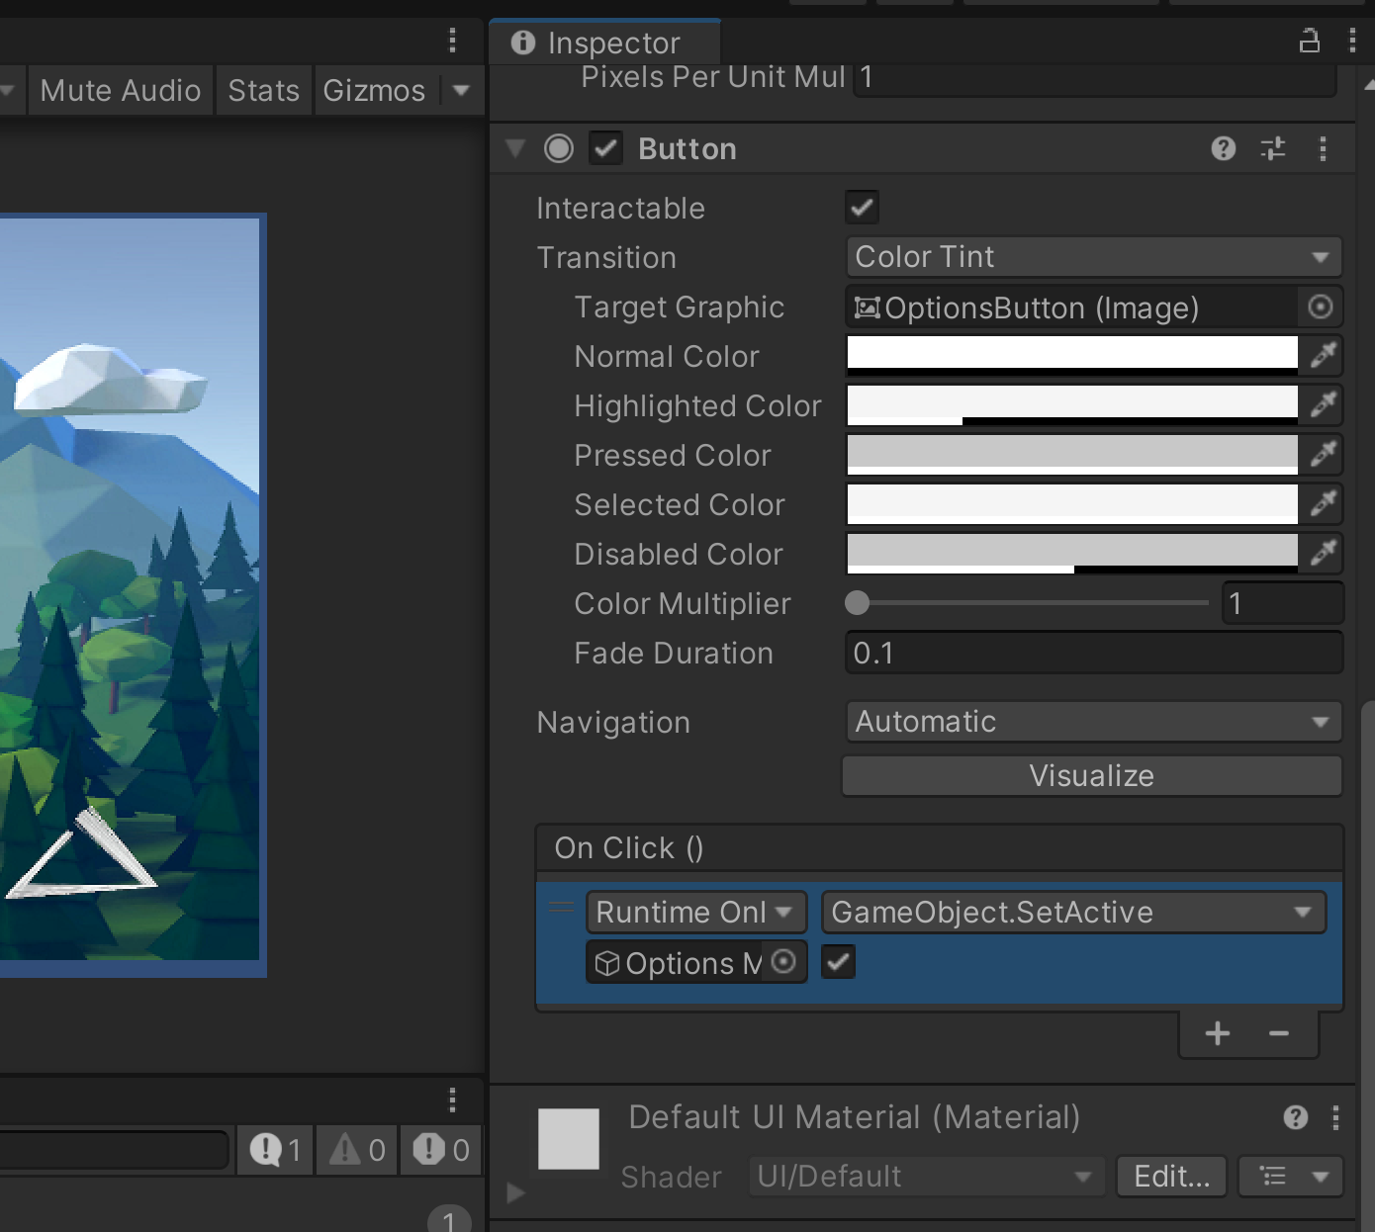

Part of the unity UI events is the fact that we can call functions on unity components and then we can choose whether or not we want the GameObject to be enabled and in this case we do but we also need to disable our main menu; so we'll just add another action this time we'll reference our main menu we'll again go under GameObject choose SetActive and this time we want it to be false.

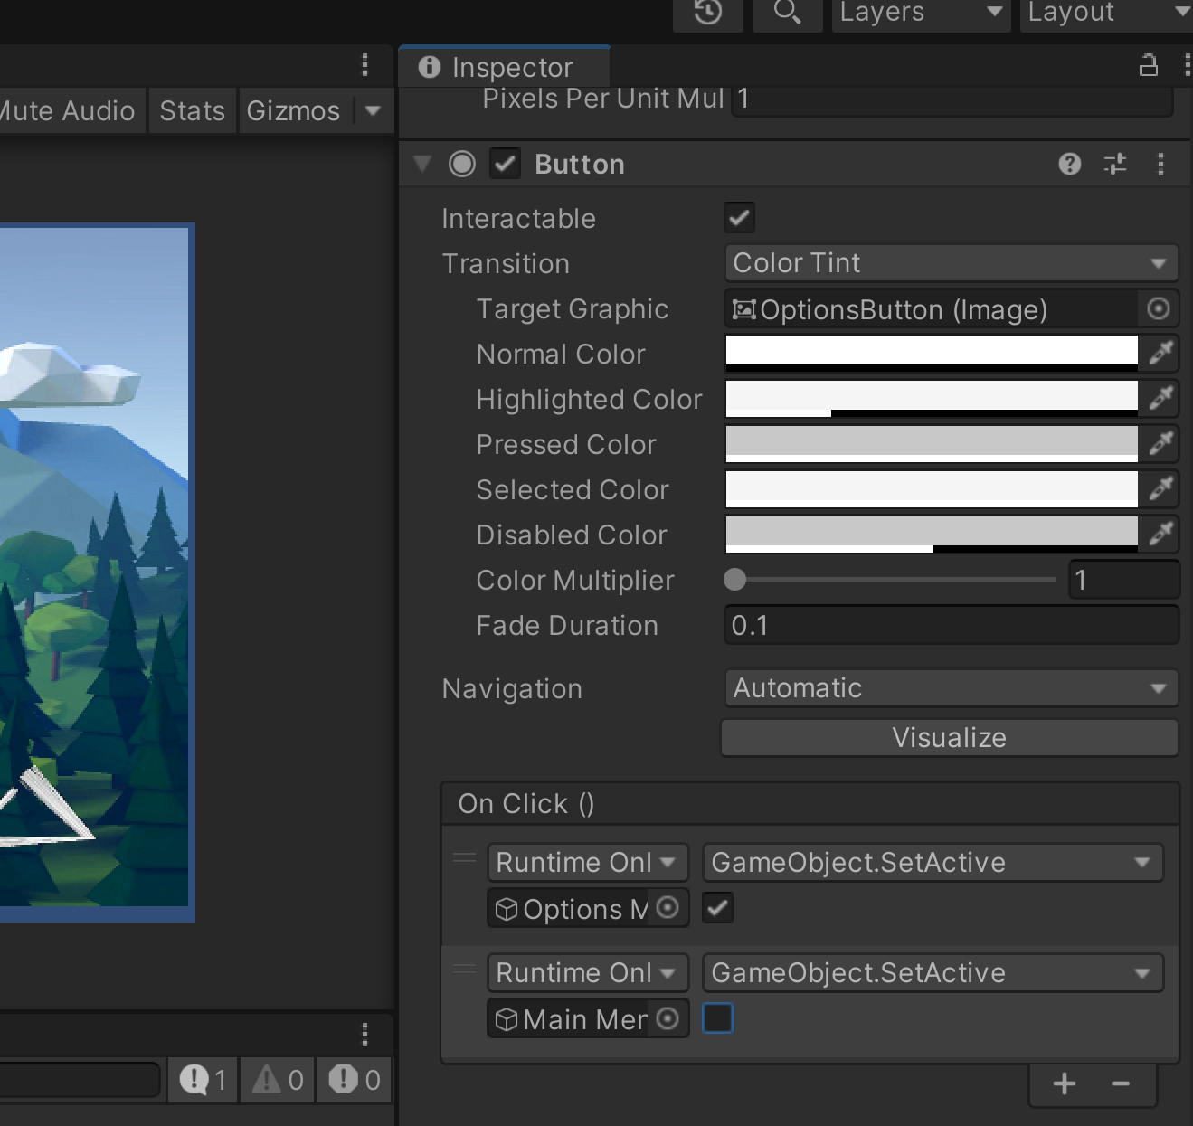

Now if we play the game and select our options, we can see that our main menu gets disabled and our options menu gets enabled. Of course, we also need to be able to transition back using the back button. To do that we'll go under the options menu select our back button add an action and here we want to reference our main menu go under GameObject, select SetActive and we'll set that to true and then we want to disable our options menu, so we'll add another action drag in the options menu go GameObject, SetActive and this time false and that completes our menu.

